IGCSE Geography – Documentary Time!

You are going to be watching a documentary that first aired in 2009. A lot has changed since then but the fundamental processes remain the same.
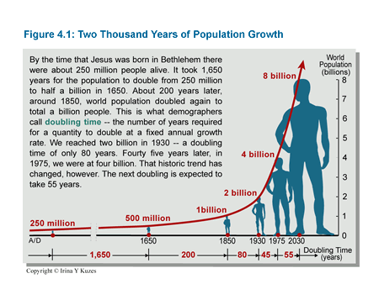
Something to think about below and that links to your last lesson where you plotted global population growth.

How Many People Can Live On Planet Earth?
- How many people live on earth? __________________________(2009) – in 2021 it is approximately 7.8 billion

- How much does the world’s population increase by each year? ___________________

- Name two environmental problems that population density contributes to

_________________________________________________________________________________

_________________________________________________________________________________

- What does the UN predict the world’s population will be by mid century?___________

- By 2050 which country will have overtaken China to become the most populated in the world?_______________

- Name two countries where population will shrink? ________________________________________________ _________________________

- The parts of the world where the population will grow fastest are rich or poor? _________

- Since 1890 how have the world death rates been reduced? ___________________________________________________________________

___________________________________________________________________

- What fundamental ingredient for life are we running out of? _____________________

- How many people on the planet lack access to safe water?
____________________________________________________

- Within the next 20 years how many people will live in areas of water stress?______________

- How much of the entire land surface is already being used to produce food?
______________________________________________________________

- What are the world’s richest countries acquiring from the very poorest?
______________________________________

- Why are the HIC’s (high income countries) using land in LIC’s (low income countries)? _______________________________________________________________________________________________________________________________________ __________________________
- How many years will it take for Rwanda’s population to double? __________________

- What is carrying capacity? __________________________________________________________
_______________________________________________________________________________

- The earth’s population would need how many earths to support the world’s population with our current way of life? ____________________

- What are the three ways we could reduce our impact on the earth?
___________________________________________________________________________________________________________________________________________________________________________________________________________________________________________________

- What policy was adopted in China in 1979?
________________________________

- What did they encourage in the 1970’s in India to reduce the birth rate?
_________________________________________________________________

- How does a good education help to reduce birth rates?
___________________________________________________________________
_________________________________________________________________

- Across the world what fraction of married women don’t have access to contraception? _____________________________

- How many has the world’s population increased by during this video? ____________________

