How is the pattern of land use changing in Toulouse?
The Growth of Toulouse
- Annotate on to your map the Geographical siting factors of Toulouse.

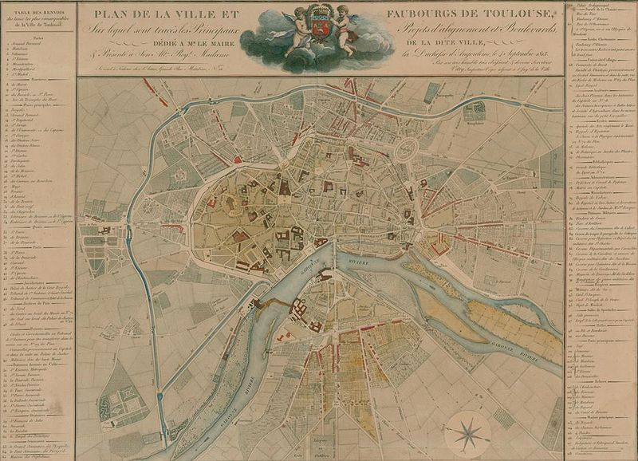

- Annotate on this map the reasons for the continued growth of Toulouse

Toulouse is now a connurbation of over 1.1 million inhabitants. List down four outlying towns and villages that have been swallowed by the growth of Toulouse.
1.
2.
3.
4.
What does this sign mean? Have you seen it out and about on your travels ?
____________________________________________________________________________________________________________________________________________________________________________________________________________________________________________________________________________________________________________
Where did Toulouse grow from (name the zone or street)
______________________________________________________________________________________________________________________________________________________
Complete your Toulouse transect showing zones of the city.
Name two types of land use that work well together and explain why.
______________________________________________________________________________________________________________________________________________________
Name two types of land use that can cause conflict with each other and explain why ?
______________________________________________________________________________________________________________________________________________________
Name a residential area of Toulouse conurbation that is desirable to live in and explain why
____________________________________________________________________________________________________________________________________________________________________________________________________________________________________________________________________________________________________________
Name a residential area of Toulouse conurbation that is undesirable to live in and explain why.
____________________________________________________________________________________________________________________________________________________________________________________________________________________________________________________________________________________________________________
How can the reputation of an area be improved? Who decides?
_________________________________________________________________________________________________________________________________________________________________________________________________________________________________

