G8 Geography - How does wealth vary around the world?
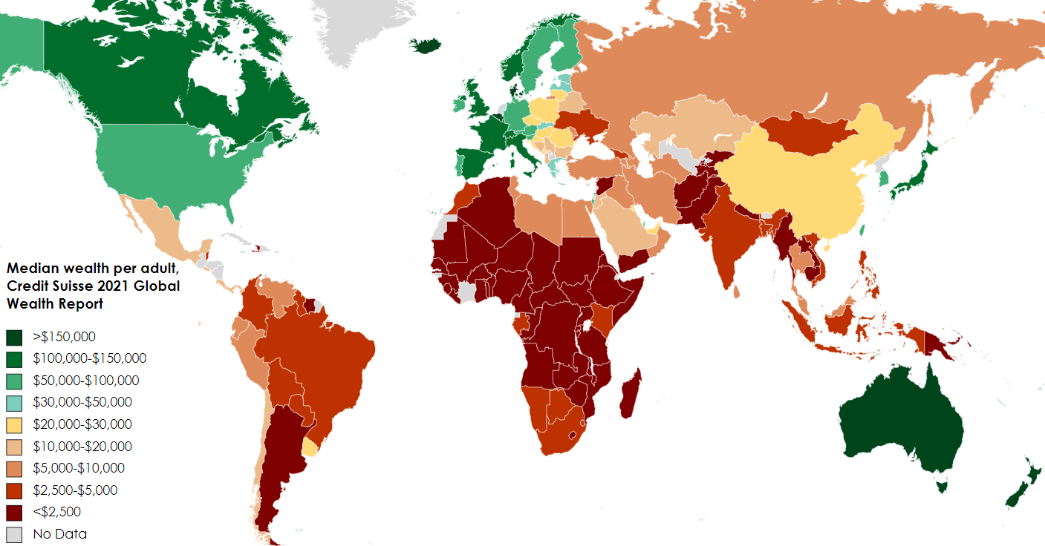
Describe where the world wealth is concentrated, and where it isn’t in the map above.

What is the GDP per capita of your home country?
County:
$______________ | Exchange rate calculator – click here  Local currency: _________________

Enter screenshot of the two charts from the wealth calculator in the space below.

Enter the first screenshot of the CEO’s wealth below.

Who is the CEO and how have they made their fortune?

Enter the second screenshot of the CEO’s wealth below.

Who is the CEO and how have they made their fortune?

Poster / Infographic Task – How is wealth unevenly distributed around the world?

Complete this task in the space below.

