GCSE Geography – Natural Hazards Revision Session – June 2013
Case Study | Dates & Times | Magnitude | Human Impact | 20 word summary
USA Quake
Haiti Quake
Hurricane Katrina
Cyclone Nargis
Etna Eruption
Nevado del Ruiz Eruption
Australia Drought
Horn of Africa Drought  A hazard is ….. |  |  |  | A disaster is…….
Explain how droughts and tropical storms differ in their speed of onset.
__________________________________________________________________________________________________________________________________________________________________________________________________________________________________________________________________________________________________________________________________________________________________

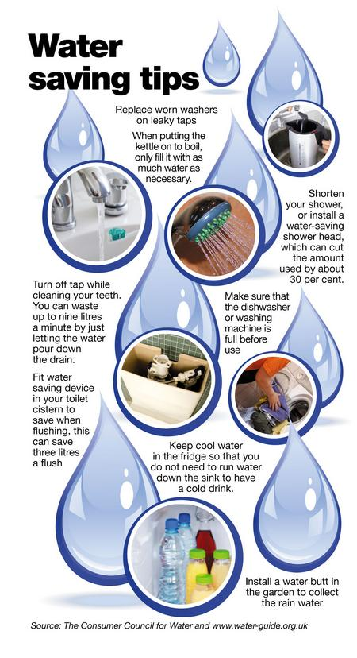
Name and locate an example of a climatic hazard.
___________________________________________________
Explain how people responded to that event in the area. Include at least three developed ideas (8)
____________________________________________________________________________________________________________________________________________________________________________________________________________________________________________________________________________________________________________________________________________________________________________________________________________________________________________________________________________________________________________________________________________________________________________________________________________________________________________________________________________________________________________________________________________________________________________________________________________________________________________________________________________________________________________________________________________________________________________________________________________________________________________________________________________________________________________________________________

Look at the poster to the right hand side which shows how people in MEDC’s try to overcome the problem of drought. Choose on tip and explain how sustainable it is. (4)
____________________________________________________________________________________________________________________________________________________________________________________________________________________________________________________________________________________________________________________________________________________________________________________________________________________________________________________________________________________________________________________________________________________

Describe the physical conditions required for the formation of tropical storms (3)
________________________________________________________________________________________________________________________________________________________________________________________________________________________________________________________________________________________________________________

Explain how people in LEDC’s can be protected and made aware of the dangers of typhoons (4) ________________________________________________________________________________________________________________________________________________________________________________________________________________________________________________________________________________________________________________________________________________________________________________

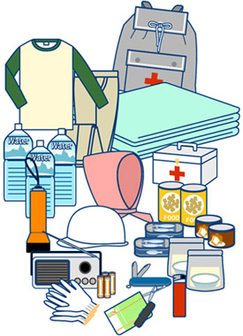

Explain how the movements of plates can cause earthquakes at conservative (passive) margins. You may draw a labeled diagram as part of your answer (4)
____________________________________________________________________________________________________________________________________________________________________________________________________________________________________________________________________________________________________________________________________________________________________________________________________________________________________________________________________________________________________________________________________________________________________________________________________________________________________________________________________________________________________________________________________________________________________________________________________________

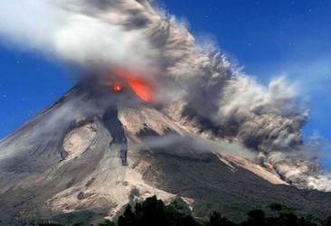

Many people die in the hours and days following a serious earthquake event. Explain how three of the items above can help people to survive the secondary effects of an earthquake.
_____________________________________________________________________________________________________________________________________________________________________________________________________________________________________________________________________________________________________________________________________________________________________________________________________________________
Use the diagram above to describe three dangerous features of a volcanic eruption. (3)
- _________________________________________________________________________________________________________________________________
- _________________________________________________________________________________________________________________________________
- _________________________________________________________________________________________________________________________________

Explain how the procedure on the left can help to protect people during an earthquake (3) _____________________________________________________________________________________________________________________________________________________________________________________________________________________________________________________
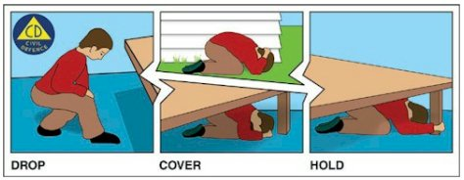

Case Study – Tectonic Event
Name and locate two volcanic eruptions; one in an MEDC and one in an LEDC
MEDC ___________________ LEDC __________________
Describe and explain the differences in the effects of the volcanic eruption on the vulnerable populations. (8)
__________________________________________________________________________________________________________________________________________________________________________________________________________________________________________________________________________________________________________________________________________________________________________________________________________________________________________________________________________________________________________________________________________________________________________________________________________________________________________________________________________________________________________________________________________________________________________________________________________________________________________________________________________________________________________________________________________________________________________________________________________________________________________________________________________________________________________________________________________________________________________________________________________________________________________________________
Case Study – Climatic Event
Name and locate two tropical storms; one in an MEDC and one in an LEDC
MEDC ___________________ LEDC __________________
Describe and explain the differences in the effects of the tropical storm on the vulnerable populations. (8)
________________________________________________________________________________________________________________________________________________________________________________________________________________________________________________________________________________________________________________________________________________________________________________________________________________________________________________________________________________________________________________________________________________________________________________________________________________________________________________________________________________________________________________________________________________________________________________________________________________________________________________________________________________________________________________________________________________________________________________________________________

To the left is San Francisco. The city lies on the San Andreas fault line and has suffered two major earthquakes in the last 120 years. Using the photo, describe and explain why people continue to live in such a dangerous area. _______________________________________________________________________________________________________________________________________________________________________________________________________________________________________________________________________________________________________________________________________________________________________________________________________________________________________________________________________

