Factors Affecting Vulnerability
A community's ability to deal with a hazard event.
Demographic Factors
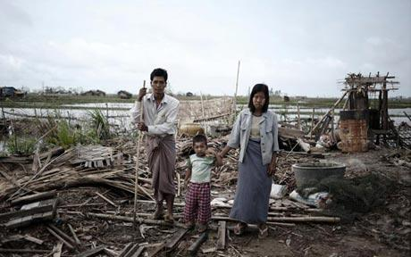
Cyclone Haiyan 2013
Community Preparedness
Socio Economic Factors

