Case Study 2 - Leisure at the international scale: sport
Locate all F1 circuits, manufactureres and drivers country of origin.
Objective: To analyse the social, cultural, economic and political factors affecting participation and success in F1 Grand Prix
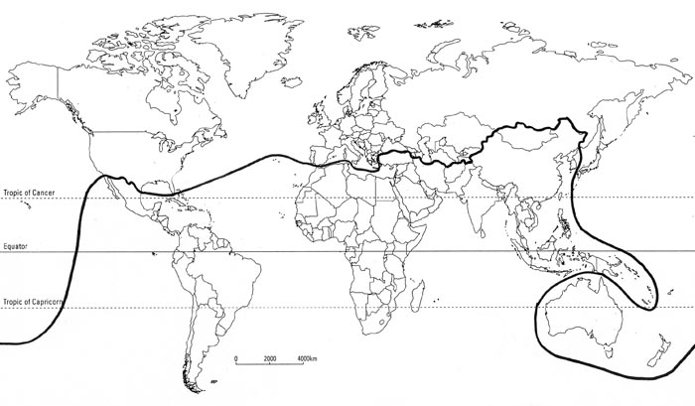
Graph to show F1 winners by continent.
Comment on global spatial pattern of constructors based on LEDC/MEDC participation. Give possible reasons for patterns identified.
Comment on global spatial pattern of F1 drivers based on LEDC/MEDC participation. Give possible reasons for patterns identified.
Comment on global spatial pattern of F1 circuits based on LEDC/MEDC spectators. Make further comment on those circuits located in the Middle East and an LEDC.

