Year 8 Geography – Planning My Globalization Essay
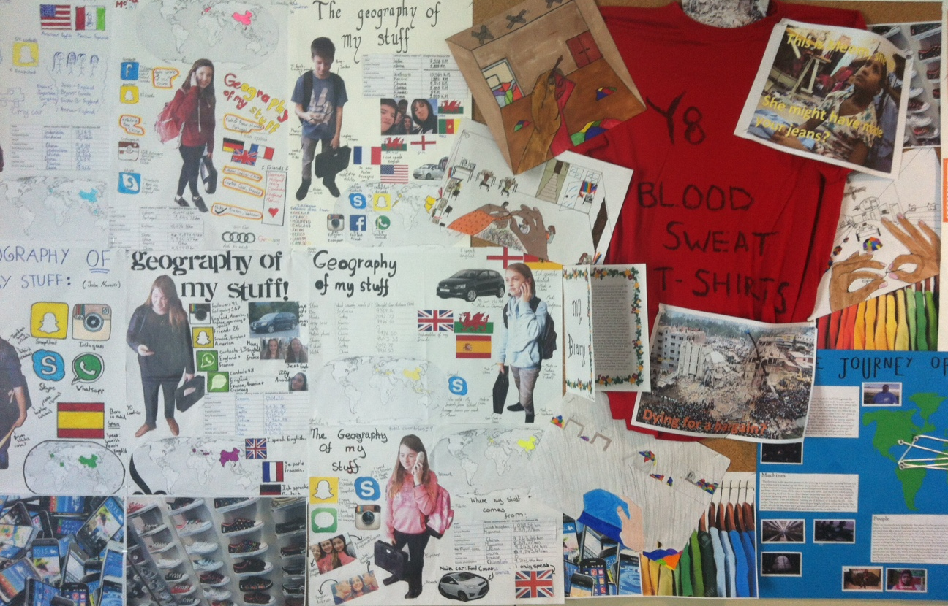
Paragraph 1 - What is Globalization? – How and where can I find a definition and then put it in my own words?

Paragraph 2 - What helps Globalization? – What helps people to share, buy, download, afford, eat, consume, connect, speak etc?

Paragraph 3 - What are the advantages/positive things about globalization? e.g. how do me and my family benefit? Thing about this things you could not do without. Why?

Paragraph 4: What are the disadvantages/negative things about globalization? e.g. who does not benefit? how does it affect me in a negative way? Think about what you have learnt about other parts of the world. Think about the environment, cultures and money.

Paragraph 5: Conclusions: What conclusions can you make about globalization? Does it make your life better or worse? Is that the same for everyone on Earth? Could you live without it? What do you rely on the most? Are there any better ways?

