IGCSE Geography – Global Population Growth

- What is the estimated global population today?

- What was the estimated global population when you were born?

- What was the estimated global population when your parents were born?

- Complete the table below:
Date | Global Population (Billion) | Time Interval (Year)
1804 | 1 | 4 million
1927 | 2 | ??
1960 | 3 | ??
1974 | 4 | ??
1987 | 5 | ??
1999 | 6 | ??
2011 | 7 | ??
???? | 8 | ????

- Using the global population graph outline, plot the data from the table above onto your graph paper and then use your graph to help you fill in the two boxes with '????' in.

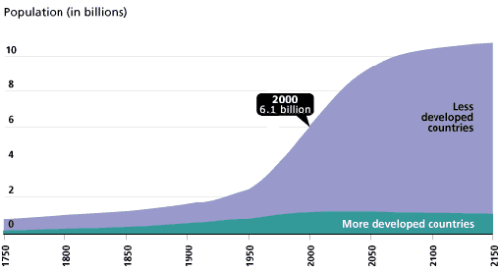
- Using ‘Historic and Future Global Population Growth’ describe the overall pattern of Global Population Growth.

- Using ‘Historic and Future Global Population Growth’ describe the contribution the ‘Less developed countries’ make to Global Population Growth.

- Using ‘Historic and Future Global Population Growth’ describe the contribution the ‘More developed countries’ make to Global Population Growth.

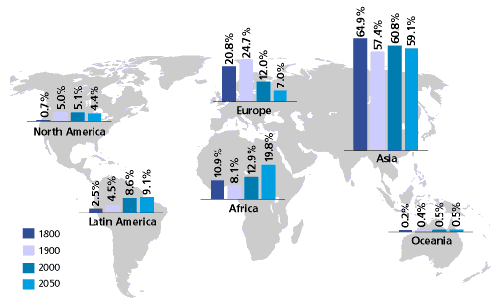
- The world’s population is not growing in a uniform way. Some regions of the world are contributing more to Global Population Growth. How has the Global Distribution of Population changed since 1800?

