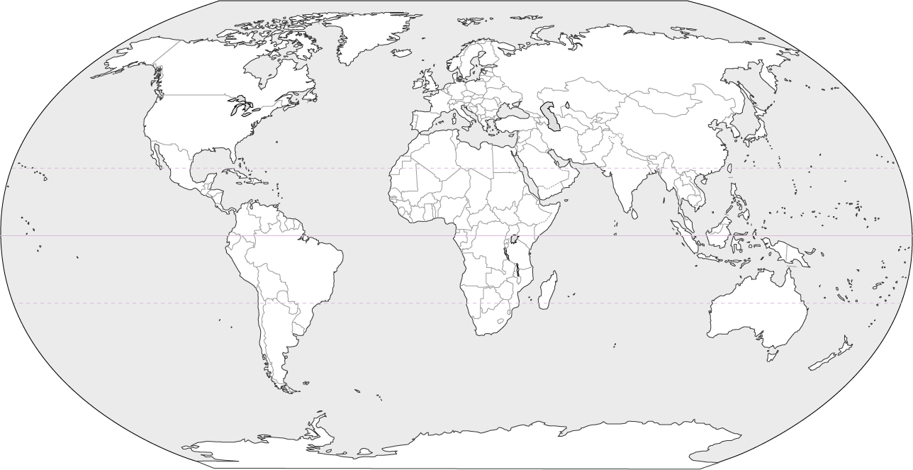
Global Locations of Tropical Rainforests – Year 9 Geography

Key

