IGCSE Geography
Spatial Distribution of Global Biomes

Watch the three minute animation. Write out some details of the characteristics of each of the eight major global biomes
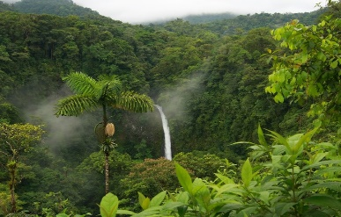

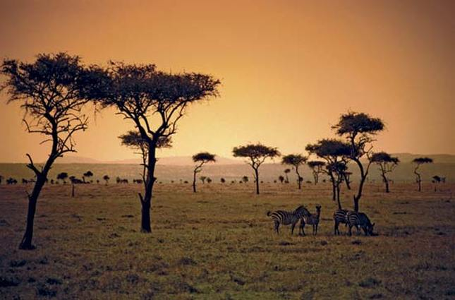

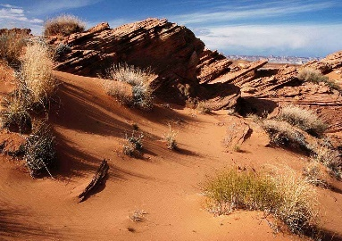

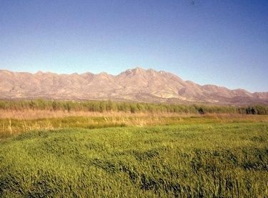

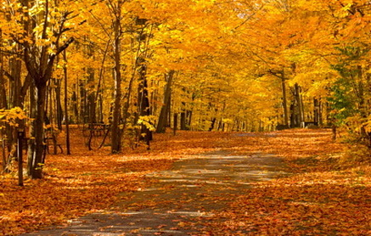

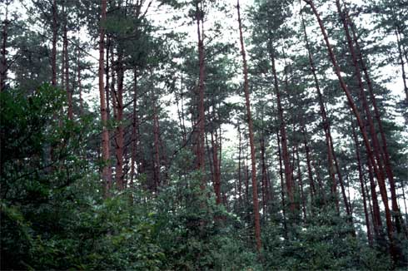

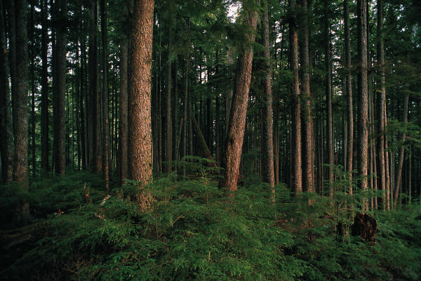

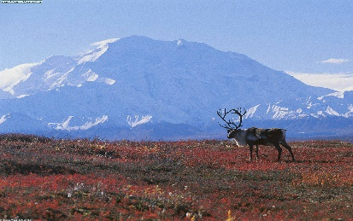

What is a biome?

What is the difference between a biome and an ecosystem?

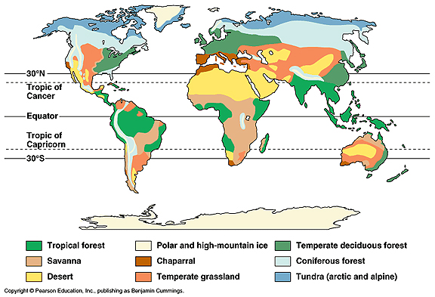

Describe the global distribution of both Desert and Tropical Forest biomes and name three countries in three different continents that host each (that's six in total).

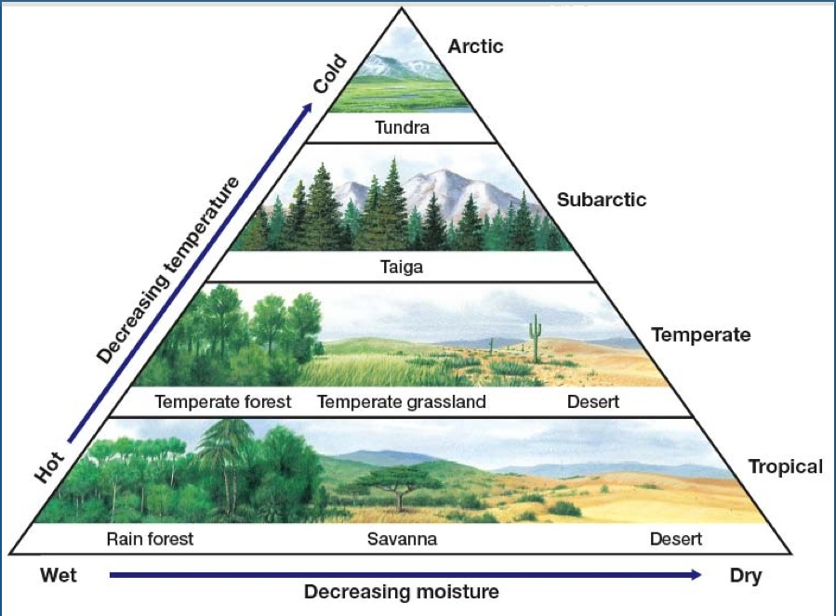

Explain the relationship between temperature & moisture and vegetation generally. How does this apply to both focus biomes (desert & rainforest)?

Personal Geography – Which ecosystems have you been to?

