|  |
| --- |
| **IGCSE Geography 2022 - 2024 – What is it all about?** |

**Dear G8 Geography Student**

You may be interested in taking Geography at IGCSE level. You have worked hard in G8 and built up a number of important skills that will be required at the next level. These include:

* 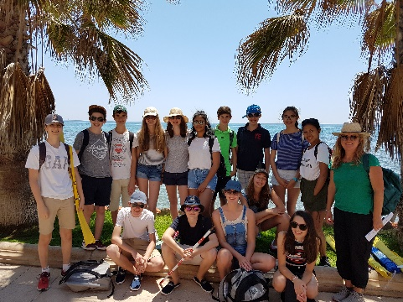Being organised
* Meeting Deadlines
* Work independently
* Factfulness
* 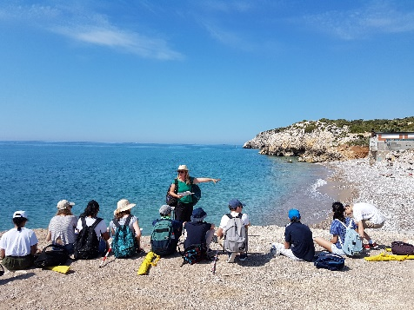Keeping up with global news events
* Extended writing
* ICT literate
* Good at presentations
* Can work with other people on a task

**Need to know**

The Geography department is well-resourced and encourages you to work independently and to gain the skills necessary to further your knowledge and understanding and perform well in a variety of tasks that will help you to understand your world. The structure of this IGCSE qualification includes one field work visit to Spain (COVID pending), one piece of coursework and two exams. The coursework project is completed in May – June of 2023 and both the external examinations are in May 2024.

The best people to ask are the current group of Grade 9 or 10 students studying IGCSE Geography. They are very approachable and would be willing to give you any information you need.

**Common questions**

***“I only have limited options, why choose Geography?”***

We believe that you should take Geography because it helps you:

* **to** understand the environment at local and global scales
* **to** know your world through fieldwork
* **to** make decisions that balance environmental and developmental concerns
* **to** develop a wide range of skills such as presenting arguments or map skills
* **to** use computers and other technology
* **for** analysis / presentation
* **to** understand other cultures in France and throughout the world
* **to** know where places in the world are …… without having to use Google!

The fieldwork to Spain and the adventurous nature of our school population allows our students to experience the very things that they are learning about. We are privileged to live in a part of the world that is geographically diverse in both its physical and human characteristics and we have exciting Geography on our doorstep.

**Some Facts (real ones….)**

* Geography is one of the most popular optional IGCSE’s in International Schools around the world.
* Geography links extremely well with History, Business Studies as well as specialist science and arts subjects, so it is ideal for a balanced curriculum
* **Geography has one of the highest rates of graduate employability, as well as being highly valued by employers worldwide.**
* The qualification leads on to IB at IST and AS/A2 level Geography in other schools and contains all the knowledge, skills and understanding necessary for further study.

**The course covers three main areas:**

**1. Paper 1 - 1 hour 45 minutes -** Candidates answer three questions out of six. There are two questions set on each of three themes. Questions are structured with gradients of difficulty and are resource-based, involving problem solving and free response writing. (75 marks) **45% of total marks**

**2. Paper 2 - 1 hour 30 minutes -** Candidates answer all the questions. The paper is based on testing the interpretation andanalysis of geographical information and on theapplication of graphical and other techniquesas appropriate. The questions will not requirespecific information of place. One question isbased on a 1:25 000 or 1:50 000 topographical map of a tropical area such as Zimbabwe, the Caribbean or Mauritius. (60 marks) **27.5% of total marks**

**3. Paper 3 - Coursework** – Linked in with the coastal unit of work. A 4 day Fieldwork may be undertaken in Spain in May 2022 (approx. €350.00). 2000 words. (60 marks) **27.5% of total marks**

|  |  |  |  |
| --- | --- | --- | --- |
| **Course Structure** | **Number** | **When** | **Percentage of final mark** |
| Paper 1 | 1 | May 2024 | 45% |
| Paper 2 | 1 | May 2024 | 27.5% |
| Coursework | 1 | May – June 2023 | 27.5% |

**Who can do Geography?**

If you choose geography you must be prepared to work hard! We encourage all of our learners to be independent and thoughtful in their studies. Group work, decision making, mysteries, mind mapping, video making, quizzes and presentations are all part of the package.

As well as combining well with other subjects, Geography itself contains many skills which can be demonstrated in other subjects.

**Will Geography be useful to you in the future?**

Geography will help you to be more aware of everyday situations and issues faced by the people who live around you, in other parts of the France, and across the world. Geography is a highly topical subject, ever changing as world events unfold. When you see newspaper articles or television reports about a potential cataclysmic ‘supervolcanic’ eruption in the USA or the Corona Virus, your Geography course will help you make sense of what is going by making balanced judgements. Geography will make you an aware and become a better-informed citizen. Choosing Geography with other subjects that interest you could lead to a promising future career. Some combinations are listed below along with the type of jobs you could expect to consider.

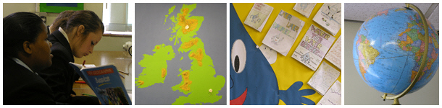

**POTENTIAL CAREERS**

**IGCSE GEOGRAPHY WITH…**

**Art + Design Technology**

**Advertising, architecture, cartography, landscape design, surveying.**

**Science**

**Agriculture, environmental health, sustainability, nature conservation, hazard management, biodiversity.**

**Archaeology, law, museums, publishing, politics, teaching & lecturing,**

**History**

**Business, overseas marketing, leisure; travel and tourism, geopolitics, human resource management.**

**Modern Languages**

**Civil engineering, meteorology, navigation, photography, demography**

**Maths**

**Leisure services, sport and recreation management, social and youth work, surveying, transport services, banks, building societies, business, civil service, police, army, health service, teaching, lecturing**

**Business Studies**

All the work that we do can be found on the teaching site specially created for IST Geography students – [www.geographypods.com](http://www.geographypods.com) Navigate to the IGCSE dropdown menu and you’ll get a feeling for the topics we cover. We use ManageBac to manage our homework tasks and will start to make more use of Windows Teams to allow collaboration when we are away from school.

The department also has a Twitter Feed @mattpodbury or follow #ISTlive. Essentially, everything is in place to help you achieve your potential.

The choice is yours and yours only. You must pick the subject that you feel happy with. If you have any further questions about your options, your first port of call should be your Year Group Coordinator or Form Tutor.

Thanks for all your hard work so far this year, keep up the excellent effort and enthusiasm.

Mr Podbury

podbury_m@intst.net

[@mattpodbury](https://twitter.com/MattPodbury) … feel free to follow me.

|  |
| --- |
| **Preparation for Grade 8 Parents Meeting** |
| Am I interested in studying IGCSE Geography at IST? |
| Do I want to combine it with either History or Business Studies? |
| After looking at what we do on geographypods.com, what am I most looking forward to studying? |
| Is there anything that worries me about the subject? |
| A 2000-word coursework assignment is required at IGCSE Geography level and is worth 27.5% of your total IGCSE Geography grade. What was your recent grade in your Palm Oil assessment and how did you feel about this piece of work?  Grade |