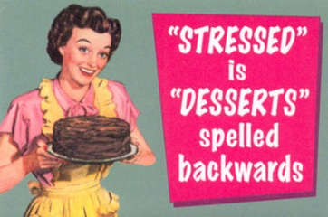
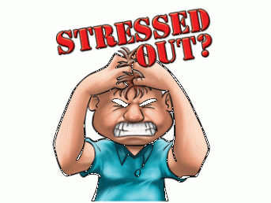
GCSE Geography @ IST
Focused Revision List for January 2012 Mocks
Hazards - Can you ….
- Explain how and where tropical storms form?
- Do you remember the different names for the storms in different parts of the world?
- What were the effects of the two case study storms in both the USA (Katrina) and Myanmar (Nargis)?
- How can people protect themselves from the impacts of this sort of climatic hazard?
- Remember where the worlds’ deserts are located?
- Remember the different plate boundaries and how they work(there are four)?
- Explain which boundaries are associated with earthquakes and which with volcanoes?
- Remember the main tectonic plate names?
- Remember how earthquakes occur? What is the ‘focus’ and ‘epicenter? How are they measured? What is the relationship between frequency and magnitude?
- Describe how earthquakes can be predicted? Or can they??
- Remember the ways that populations from MEDCs and LEDCs can plan and prepare for the next big earthquake?
- Remember and recount what happened in the Nevado del Ruiz volcanic eruption in Mexico? What were the responses and effects?
Economic Development - Can you….
- Remember what PSTQ industries are and where they tend to be located?
- Write down what the difference is between wealth and development?
- Explain how we can measure development?
- Define what HDI is and what does it measure?
- Explain what is a multinational company is and how and where they tend to operate? What are the associated issues? NIKE!
- Remember your Pearl Delta, China, case study of the environmental impacts of the concentration of industry there?
- Define literacy rate, birth rate, death rate, life expectancy, infant mortality rate etc?
- Write about what Aid is and how it can affect development?
- Write in detail about the Goat Aid/ Computer Aid case study (from OCR textbook)
- Remember what made the M4 such a good location for quaternary industry?
- Explain the concept of global warming and the greenhouse effect and link economic development to it? How is the problem being combatted?
- Do some additional research on the Kyoto Deal that was set out in 1997. You will see that is has been back in the news recently. What have Canada done? Is this a good thing?

