Name ?????
The Global Hydrological Cycle

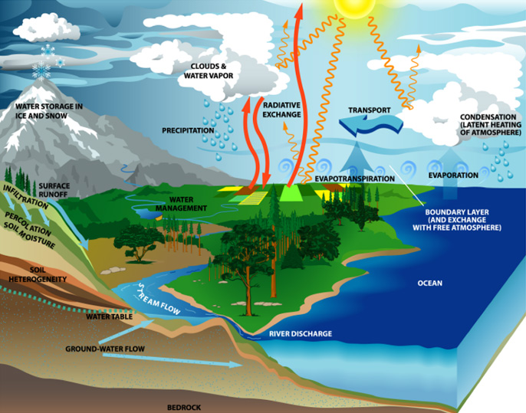

Choose the correct term for the definitions.
The movement of water through plant cells into the atmosphere.
Movement of water confined within a river or stream.
The movement of water into the soil layers.
The processes by which water reaches the soil or surface.
Trees and other vegetation, which prevent moisture from reaching the ground directly.
Movement of water from vegetation to the ground surface.
The upper level of saturated rocks; it may move between seasons and years.
Movement of water through the soil, either under gravity, or parallel to the ground surface.
Movement of water over the ground surface (also known as surface runoff).
The combined processes by which water is lost by evaporation and transpiration.
The processes by which water moves through the landscape.
The change of state from water as a liquid into water vapour (a gas).

Study the diagram of the global hydrological cycle (above). List 10 processes shown in the diagram and explain what would cause these processes to increase and decrease.
Process | What would cause this process to increase? | What would cause this process to decrease?
Transpiration | Higher humidity / temperatures | Lower temperatures / less vegetation
Channel Flow | Higher precipitation / more rivers | Drought
Infiltration | Removal of vegetation | Hard baked soil / impermeable surfaces
Precipitation | The seasons (winter) | Global warming changing weather patterns
Interception Rate | More vegetation, tropical rainforests. | Deforestation
Stem Flow / Drip Flow | More vegetation / wider canopy | Deforestation / tundra
Water Table | More precipitation / winter | Drier conditions / drought / extraction of groundwater
Throughflow | Porous conditions | impermeable ground (rock or heat baked)
Evaporation | Higher temperatures | Lower temperatures
Process | ????? | ?????

List five different types of storage shown in the diagram of the hydrological cycle (above).
Storage in Hydrological Cycle 1
Storage in Hydrological Cycle 2
Storage in Hydrological Cycle 3
Storage in Hydrological Cycle 4
Storage in Hydrological Cycle 5

