G8 Tropical Climate - Why is it so hot on the equator?
Using the worksheet on geographypods, draw your own diagram in the space below and complete the fill in the blanks exercise in the space below.
Image here

On the equator, the sun..

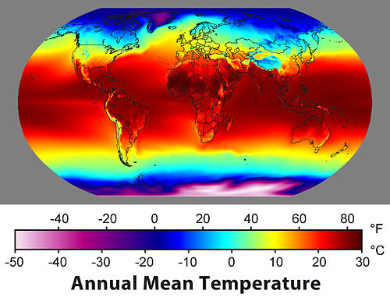

The formation of convectional rainfall.
Using the worksheet on geographypods, draw your own diagram in the space below and complete the fill in the blanks exercise in the space below.
Image here

Throughout the year, the sun is ..

