G8 Geography – Tourism Trends Over Time
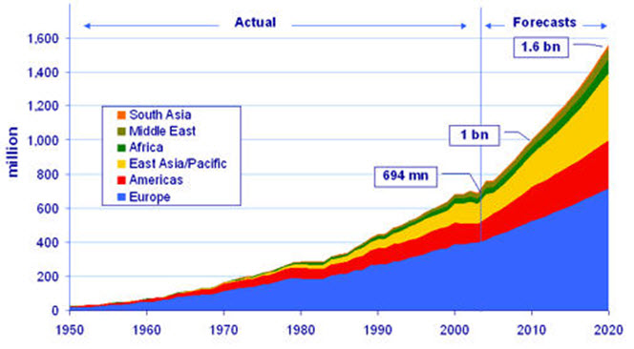
- Which region of the World has always had the most tourists visiting? What will this number be in 2020?

- By 2020, which will be the second most visited region in the world?

- Name two global regions that did not appear on the graph in the 1950's. Can you suggest any reasons for this?

- In approximately what year did tourism numbers reach 1 billion visits?

- What was the total number of tourism visits in 1950?

- Approximately what were the total number of tourist visits in 'The America's' in 2010?

- After Europe, which area of the world is expected to record the largest growth in tourist numbers?

- Identify two years where tourism slowed down or experienced a temporary reduction.

