Mexico & The Coca Cola / Diabetes Problem
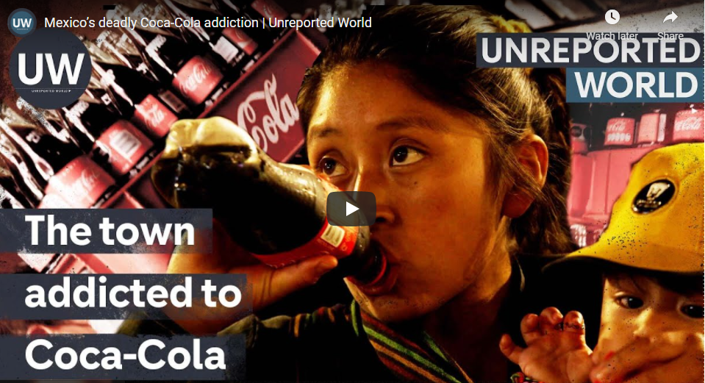
Watch the video embedded on geographypods and complete some note taking using the prompts below:

What is Mexico’s rather unfortunate claim to fame when it comes to Coca Cola?

What condition does everyone in Pedro’s family have?

What were Roberto’s symptoms?

How many people die in the town every year from Diabetes?

In 2010, how many litres of coke did people from the town drink every year?

Why does Pedro’s Mum think that so many people drink Coca Cola?

How many Coca Cola outlets did they see in 5 minutes of driving around the town?

How many gallons of water does the Coca Cola factory use every day in making the drink?

How many jobs do Coca Cola create in the local town?

What is a shaman (use Google to find out)?

How do they use Coca Cola as part of their rituals?

What does the shaman claim to be the cause of diabetes?

What did the Mexico government do in 2014 to reduce fizzy drink consumption?

How does the price of Coca Cola and water compare?

What bacteria is found in the water supply (rivers) of the town?

How much have Coca Cola reduced their sugar levels in their drinks since 2018?

