G6 Geography – Where do earthquakes happen?
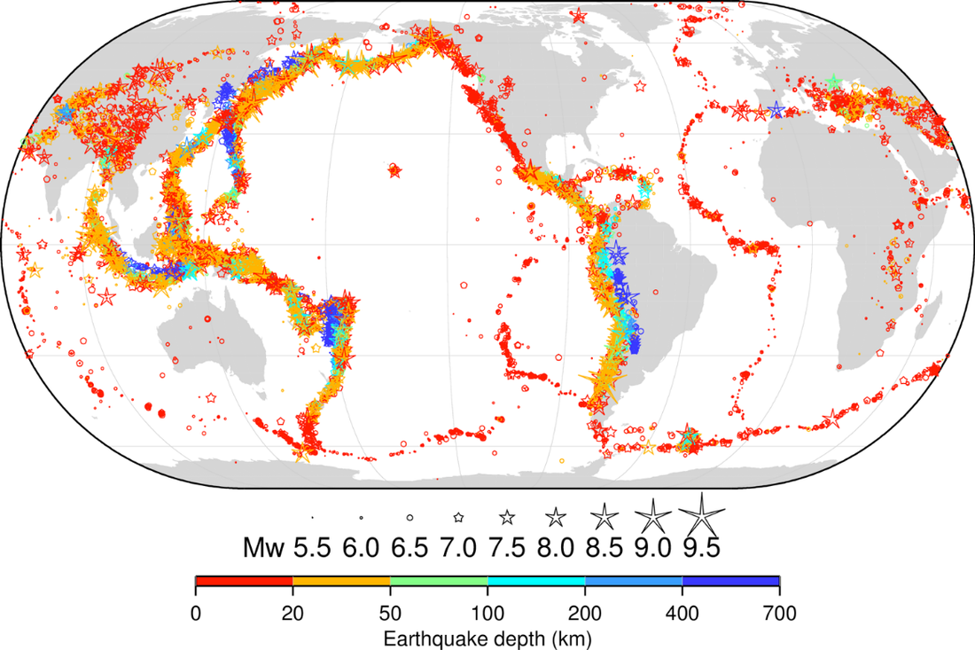
The map above shows the distribution of earthquakes around the world. Each star represents an earthquake. The size represents the magnitude (how strong it was) and the colour represents how deep within the crust it happened.

Task 1 - Using the map and video on geographypods, describe the pattern of earthquake activity around the world.

Task 2 - How does this link in to the location of major plate boundaries? (see map on next page)

Task 3 – Name two areas where very deep earthquakes happen.
1

2

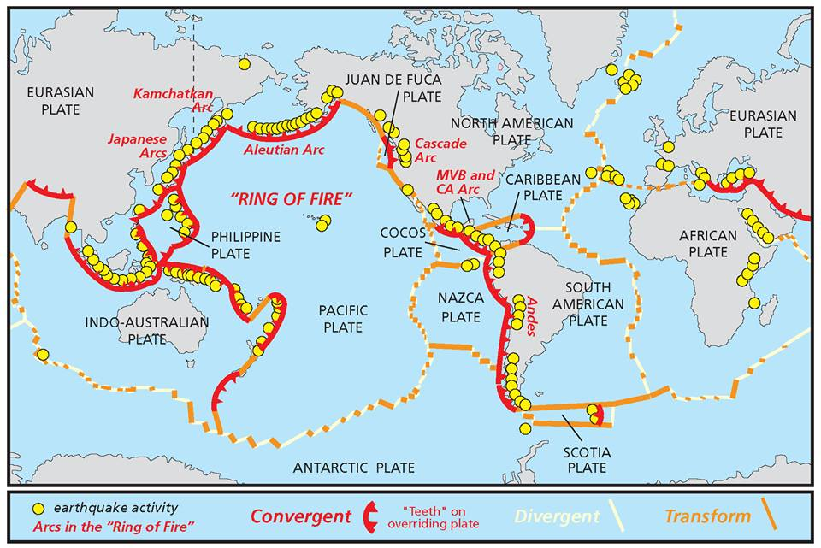
Task 4 – Using the map above and the map on the first page, identify which type of plate boundary is most associated with deep quakes.

Task 5 – Using the map on the first page, name two areas where very strong earthquakes happen.
1

2

