G6 Geography – What causes an earthquake to happen?
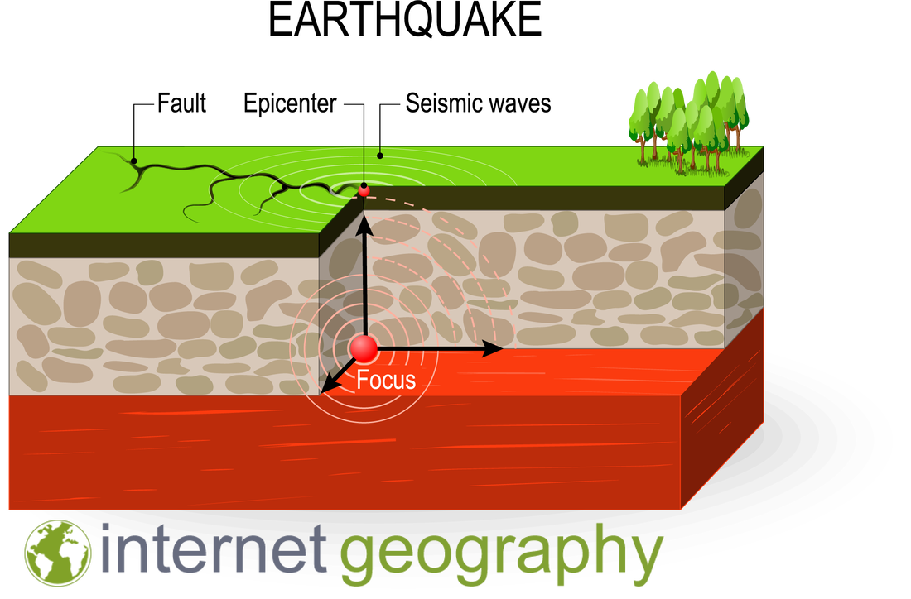

Task 1 - What is the difference between the focus and the epicentre of an earthquake?

Task 2 – Explain, with the aid of a diagram, how earthquakes happen.
You should aim to use the following words in your description.

conservative plates, friction, stress, slip, focus, epicentre, seismic waves

Draw your own basic version of the diagram on the first page of this worksheet. You can use this simple explanation video to help you.

