Fold Mountains – IGCSE Geography
To completed in conjunction with http://www.geographypods.com/4-fold-mountains1.html

Make a copy of the three sequence fold mountain formation diagram from geographypods in the space underneath.

Using the diagram above, explain how fold mountains form.

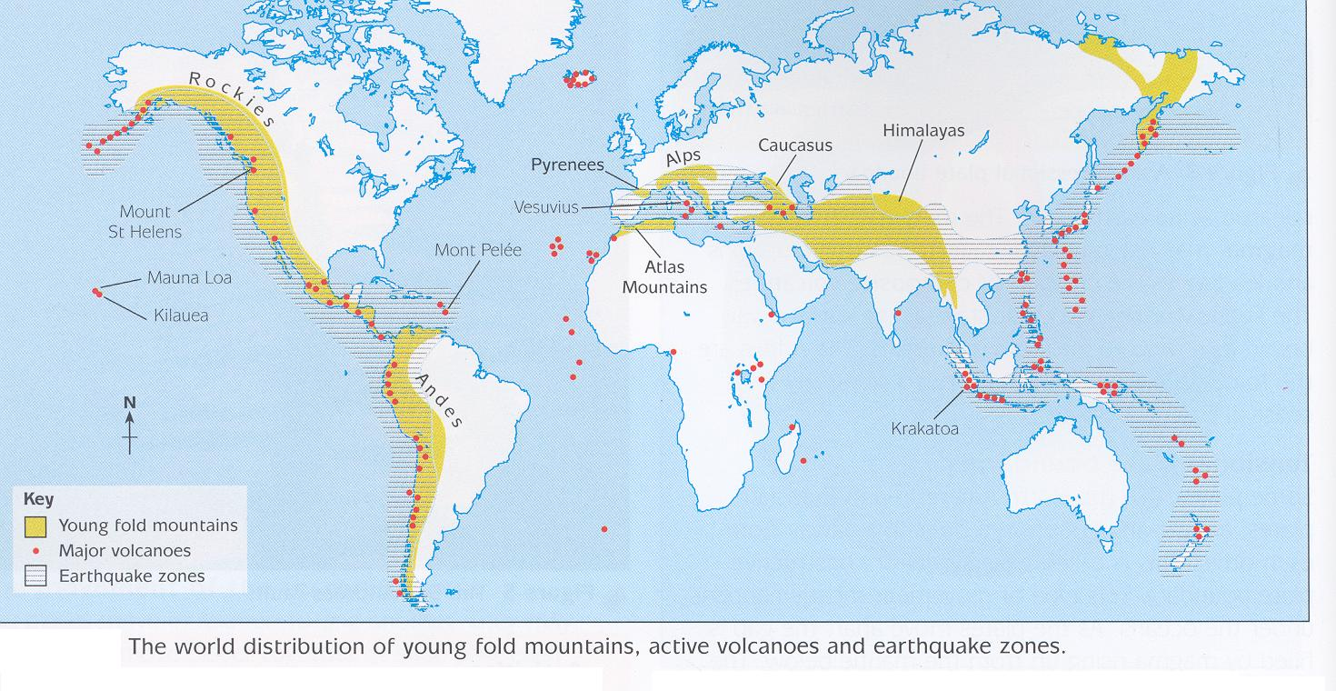

Explain the relationship between the location of fold mountains and the margins of the main tectonic plates (3)

Which type(s) of plate boundary is commonly associated with fold mountain formation? (3)

Fold Mountain Case Study – The Alps

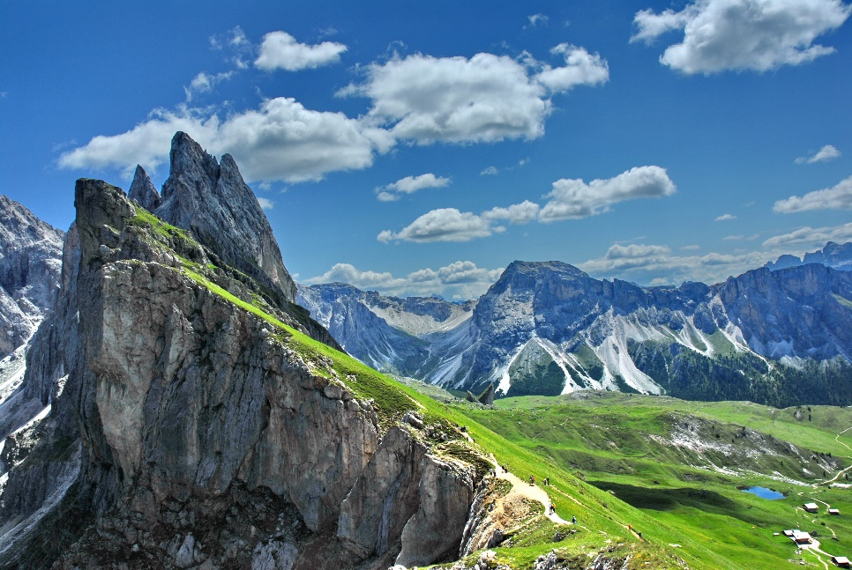

Briefly explain how and when the Alps were formed.

Advantages of Fold Mountain Landscapes | Disadvantages of Fold Mountain Landscapes

Exam Corner

What are the main human activities in Alpine Regions? (5)

Why are so many people attracted to Alpine regions? (5)

What are the main problems in living in Alpine Regions? (5)

