Brazil World Cup 2014 - Favelas – My Impression

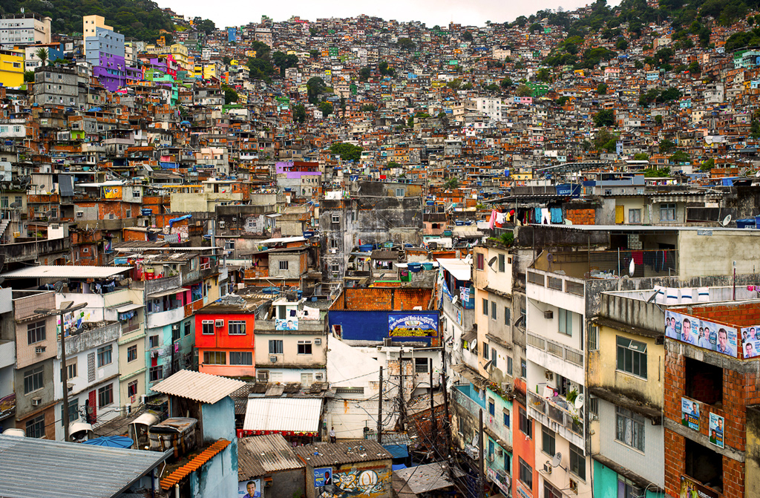
I would smell ….
I would see ….
I would hear ….

