Factors Affecting Vulnerability
A community's ability to deal with a hazard event.
Demographic Factors
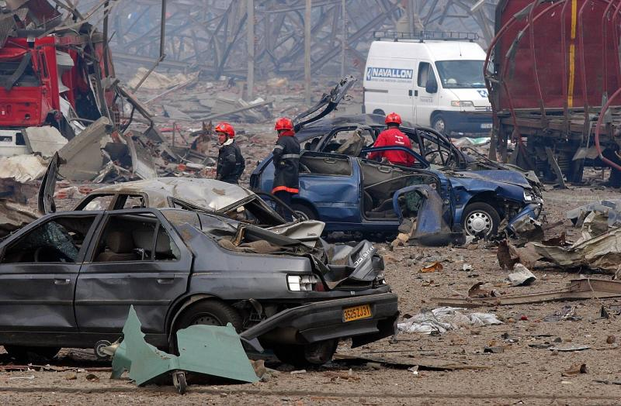
AZF Explosion Toulouse 2001
Community Preparedness
Socio Economic Factors

