Factors Affecting Vulnerability
A community's ability to deal with a hazard event.
Demographic Factors
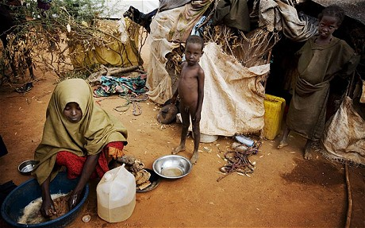
Horn of Africa Drought Ongoing
Community Preparedness
Socio Economic Factors

