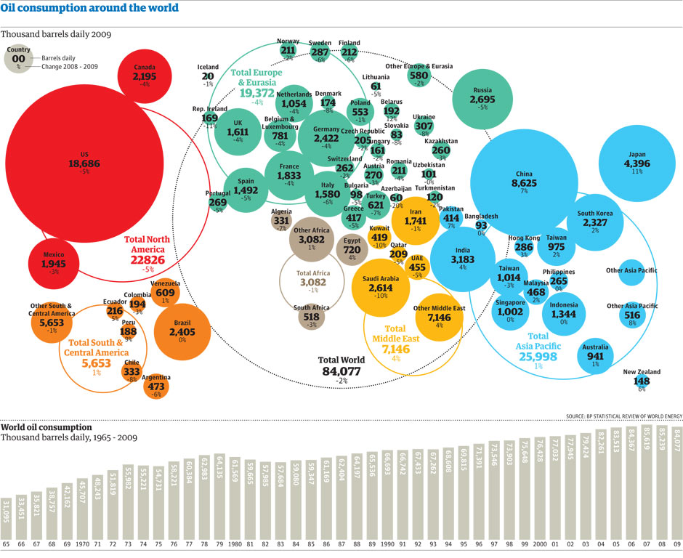

Exam style questions:
Describe the global patterns in oil consumption. [2 Marks]

Describe the global trends consumption. [4 Marks]

Explain the global patterns in oil consumption. [5 Marks]

Explain the global trends in oil consumption. [5 Marks]

