The economic effect of the 2015 earthquake on Nepal

You now know that the population worst affected by the quake are the Nepalese in the major cities and more so in the rural isolated communities. You also know that a small but significant number of international mountaineers and tourists have also been affected in the Everest region. To paint a picture of the likely effects of the earthquake on the economy, we have to compare some key development indicators between both your home country and Nepal. You will need to use the CIA World Fact Book entries for both Nepal and your home country.
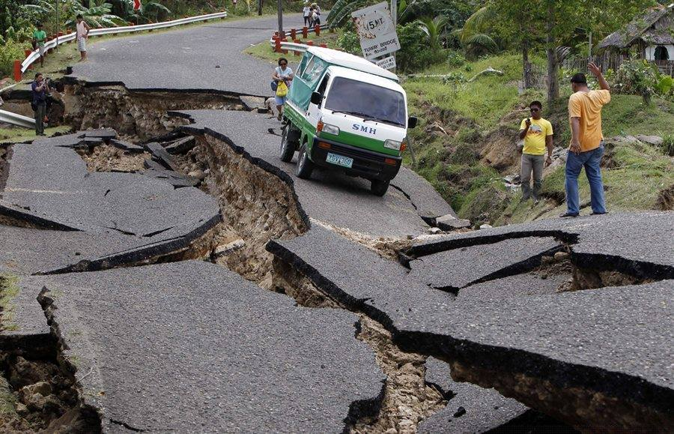

V’s

Indicator | Nepal | **enter your home country here**
People & Society
Birth Rates / 1000
Death Rates / 1000
Total Infant Mortality Rate / 1000
Life Expectancy at Birth
Literacy Rate Total Population
The Economy
GDP Per Capita
Unemployment Rate

Is Nepal developed or not & how do you know?

Is your home country developed or not & how do you know?

Watch the YouTube video embedded on geographypods – Nepal’s earthquake could cripple its vital tourist economy. Answer the following questions:
- How much of the GDP is supported by Everest tourism?

- How much do foreign climbers pay to climb Everest?

- How many tourists visited Nepal in 2013?

- What % of Nepalese jobs are in the tourist industry?

- What is the name of the major attraction in Kathmandu that completely collapsed?

