G6 Geography – The earthquake through my eyes – Journalism Task
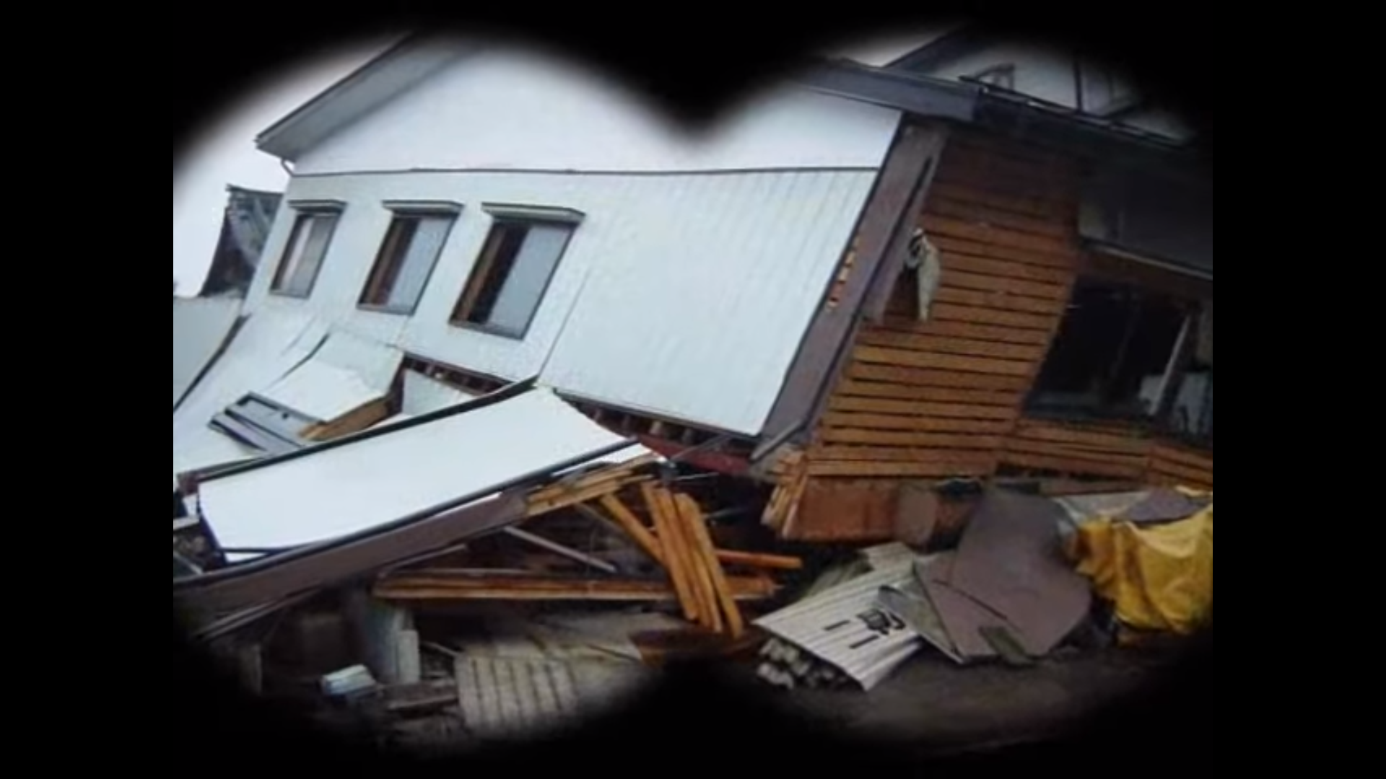

As you watch the video on geographypods, write 10 adjectives into the box below that describe the impacts of an earthquake.

The earthquake through my eyes – senses. Complete the grid below using single words to describe each sense.

Sounds | Smells
Sights | Taste

Please choose one of the scenarios below. Delete the one you don’t use. Complete the story by writing 400-500 words additional to the start of the story.

Option 1
The earthquake through my eyes (home version)
It was a normal Monday morning, and my alarm went off at 7.00am. I hit the snooze button and then tried hard to go back to sleep. I could hear my Dad in the shower and my siter was already downstairs rattling around in the cupboards looking for a plate. Mum shouted up to get up as we were going to be late to go to school. Traffic is always bad on a Monday morning and I always feel so tired after my action-packed weekends. Outside, I could hear our neighbours dogs barking and I wondered what could be upsetting them at this hour. Finally, I flung back my duvet, placed my feet onto the floor and was just about to stand up when I heard it……

Option 2
The earthquake through my eyes (school version)
It was a normal Monday afternoon, and we had just finished our afternoon break and had arrived back to the Geography classroom ready for our fabulous teacher to arrive and deliver the best lesson of the week! The lesson got started and we were watching a video on the interactive whiteboard with the blinds pulled. The class was absorbed with the video and we watched in awe as lave spewed from the crater of Mt Etna. Suddenly, the picture on the screen went all fuzzy and dust fell from the ceiling. The room started to shake and our teacher shouted ….. “QUICK, GET UNDER THE TABLES…..” Then it hit……

