|  |
| --- |
| **G7 Geography – Undercover in the ‘sweatshop** |

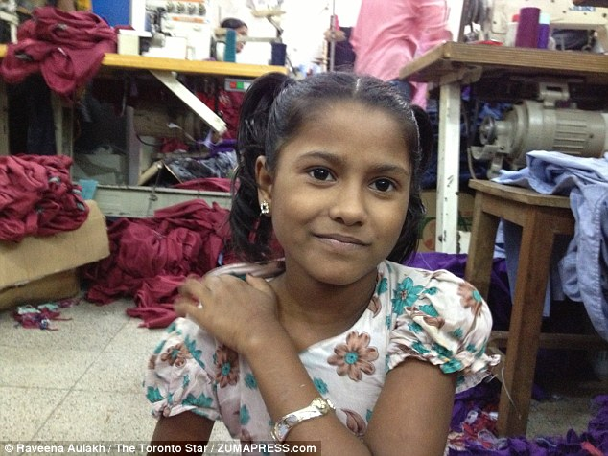

**Name**:

**Age**:

**Job:**

**Job description**:

**Workplace**:

**Hours**:

**Wage**:

**Benefits:**

School’s Out – Why I left school for the sweatshop…

**Why are child workers preferred by the bosses?**



How have sweatshops improved the lives of women in Bangladesh?

What problems can people who work in sweatshops face.

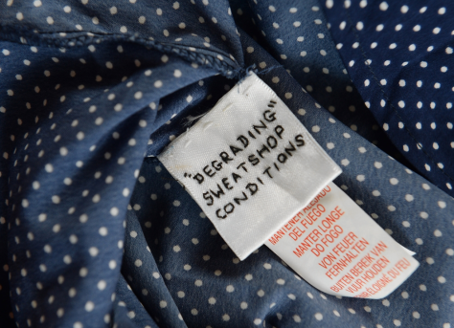

See if you can find out what the image to the right is about.