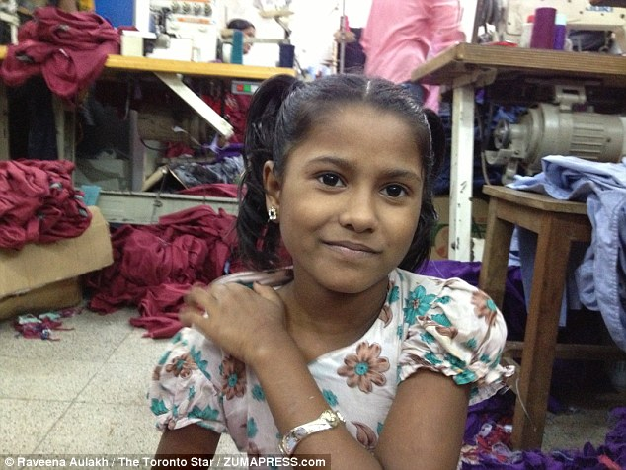**Meem’s Diary**

**Name**:

**Age**:

**Job:**

**Job description**:

**Workplace**:

**Hours**:

**Wage**:

**Benefits:**

School’s Out – Why I left school for the sweatshop…

**Why are child workers preferred by the bosses?**



How have sweatshops improved the lives of women in Bangladesh?

A day in the life of Meem. My diary.