iGCSE Geography – Why do some of us have more neighbours than others ?

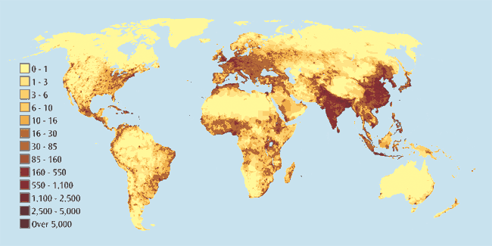
Study the map carefully. The key refers to the number of people per KM²

Densely Populated | Sparsely Populated
Task 1 – Identify the most densely and sparsely population places on earth. Name countries and give values from the key.

Task 2 – Using an atlas / Google Earth pencil sketch on the location and extent of the following physical features:
- Himalayas 2. Andes 3. Rockies 4. Atlas 5. Ural
6. Amazon Rainforest 7. Congo Basin Rainforest 8. Canadian Boreal Forest 9. Gobi Desert
10. Sahara Desert 11. Arabian Desert 12. Great Victoria Desert 13. Great Sandy Desert.
14. Northern Polar Regions

Task 3 – Answer the following question:
- What is the link between sparsely populated areas of the earth and physical features?

- How do physical features and physical features (e.g. mountains) and physical processes (e.g. cold climate) affect people and their choice of where to live? Give two examples in the space beneath

Example 1 –

Example 2 -

