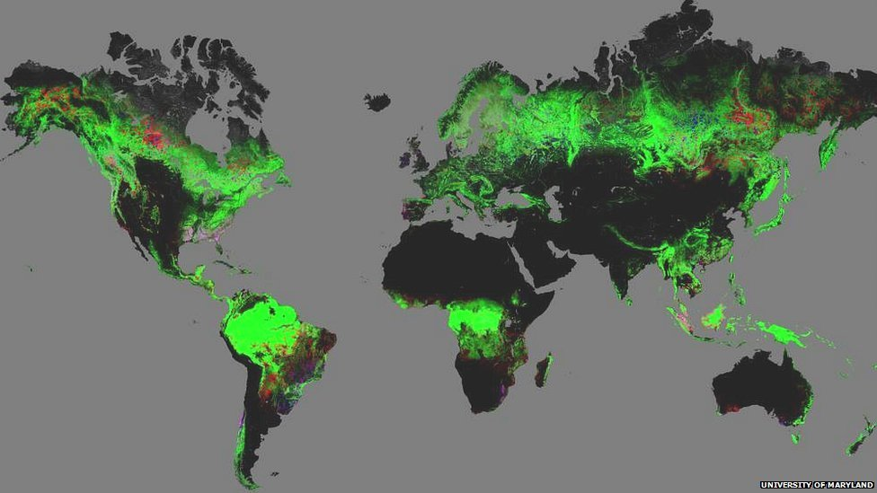
iGCSE Geography – Rainforests & Biodiversity - Global map of forest change

The map shows forest change from 2000-12. Bright green areas are forested; red suffered forest loss; blue showed forest gain; pink experienced both loss and gain.
Task 1. Comment on the patterns of suffered forest loss (deforestation) compared to forest gain (afforestation) globally between 2000-2012. Include reference to countries and possible reasons for these patterns.

Task 2. Is the problem of deforestation a problem associated with LEDC’s & NIC’s only?

