IGCSE Geography – Population & High Death Rates
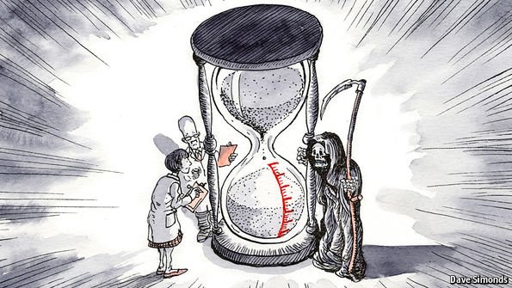

Define ‘Death Rate’

Using the information on geographypods, create spider diagram in the space below to show the seven main causes of a high death rate.

Click on this link to be taken to a page that tells you about the highest death rates in the world. In the space below, make a note of the top three countries in the world with the highest death rate and make some brief notes on why this is.
Country & Rank | Death Rate | Why so high?

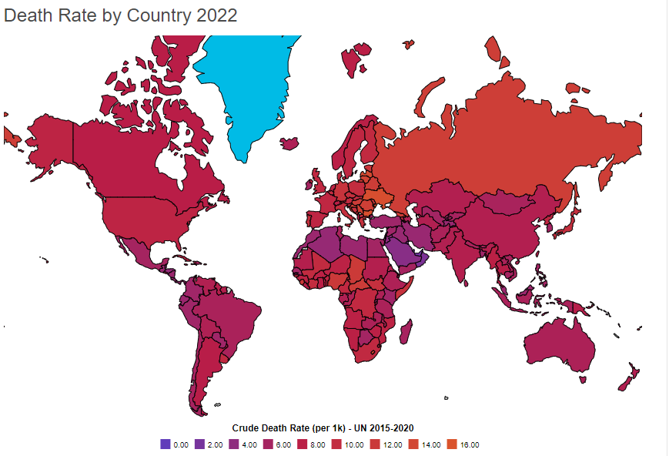

Describe the distribution of high and low death rates around the world between 2015-2020.

