iGCSE Geography – Data Interpretation (approx. 1000 Words)
You are going to split this section into two. The first part is going to be answering RQ1 and the second part answering RQ2.
Part 1 = Research Question 1 - How have geomorphic processes altered the coastline in Sitges?
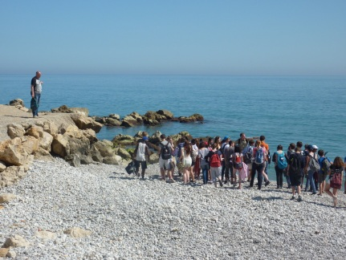
Remind the examiner that you know about the different geomorphic processes (erosion, transportation, deposition) and that the processes can be linked to the sea and the geology (type of rock under the surface)
So, what did you see in Sitges?
A way to structure this would be to look at each process– Erosion, Transportation, Deposition
Erosion
Location 1 – The Headland - Your Field Sketch & Photos
Where? – locate the headland on a map of Sitges (Google Map in Satellite view) and on your Geology Map from geographypods. Remember, the headland is a hard rock feature. Which rock is it created from? It takes longer to erode and so projects out into the sea unlike the softer rock on either side which erodes backwards at a faster rate to form bays & headlands.
What? Write about the features you saw and how they were created
Stump, Wave Cut Notch, Joints & Weaknesses in Cliff Face, Small Cave
At this point, a good IGCSE Geography student will try to explain the processes that caused each of the features and be using terminology like
destructive waves, fetch, attrition, hydraulic action, limestone, resistant rock, solution, wave attack
Location 2 – The Sandy Beaches (1-6) – Your beach shapes & photos
Where? Refer to your beach shapes (where you plotted the width on the left, middle & right hand side). Refer to your geology map and state what rock type is found underneath the area with the beaches. What is the link between this soft rock and the rate (speed) of potential erosion?
What? Beaches that are much narrower than the rest would most likely be suffering from erosion of beach material. Can you identify one or more of these beaches and suggest which geomorphic processes are causing this. Don’t add anything here about human intervention. Save that until RQ2.

Transportation
Location 3 – Sandy Beaches – Your Located Bar Chart
Where? – Beaches 1 – 6. You are looking for evidence of longshore drift. Which way does it appear to be coming from? How can you tell? Make sure you give examples of the depths from the groynes in your explanation. Make sure you explain any anomalies.
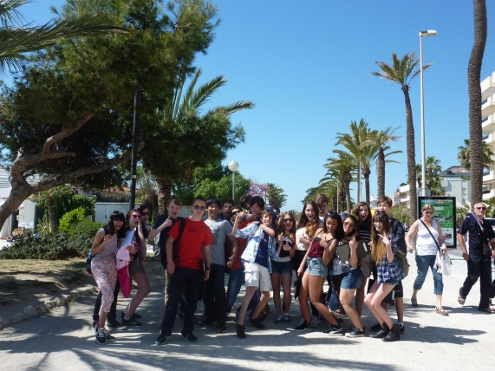
What? – Link the direction with the Wave Attack Information Sheet in your pack (with loads of arrows showing Incident Energy & Frequency). Don’t forget to explain where this sand has come from and what would happen to this sand if it was not trapped by the groynes.
Location 4 – Pebble Beach
Where? – Pebble beach close to the nightclub. You will need your compass rose sheet with directions of pebbles.
What? – Which way were most pebbles pointing? (North East or North West?). Link this to the longshore drift direction on this beach. Does this direction match your sandy beach measurements? If not, continue reading below.
If not, don’t worry! – Look at the Wave Attack Information Sheet – Are there often waves from this new direction (frequency)? If there are, then your question has been answered. Longshore drift can occur in different directions on different bits of coastline. Link your direction to this data … et voila!
Deposition (this will be a brief section)
Location 5– Any beach
Where? – Sandy beaches that were very wide according to your beach profile shapes.
What? Where has longshore drift deposited most material, but link to the fact that humans have caused this to happen more by building a particular type of coastal defence. **The best one for trapping sand**

End with a little sentence telling the examiner which processes you think has the biggest effect on the coastline in Sitges. Is it erosion, transportation or deposition? Explain briefly why you think this.

Part 2 = Research Question 2 - How have people affected the geomorphic processes on this stretch of coastline?
What you need to do here is to show that examiner that you can make links between the two RQ’s. In the previous section, you have just found out that there is loads of erosion, transportation and deposition going on. If this was left to happen without any interference from humans, what would the consequences be for Sitges?
Write a short paragraph that tells the examiner why Sitges is worth protecting. Have a think about how the key Geography words below could help you.
Tourism, Economy, 3rd Most Expensive Land in Spain, Expensive Property, Businesses, Railway, Jobs,
Erosion
How have People affected Erosion? – Sea Wall (photos)
Where? – Sandy Beach & Promenade
What? Sea Wall. Explain how the sea wall works and tries to prevent erosion.
Erosion normally provides sediment for LSD to build beaches further down the coast so what is the likely result of cutting off this supply of eroded beach material?
How have People affected Erosion? – Rock Islets (photos & bi-polar analysis)
Where? – In front of the expensive houses on beach 6 & 7.
What? Explain what rock islets are and how they work? Why would they put these right in front of the most expensive houses? What do rock islets do to the shape of the beaches here? Look at the satellite view of the beaches and your photos!
Talk about your bi-polar results (if you have some). How well do they work in your opinion. Refer to grades that you gave to the groynes you studied. If you didn’t do one in Sitges, you can do one using Google Street View!
Transportation
How have people affected Transportation – Groynes (photos & bi-polar analysis)
Where? – Sandy beaches 1-6
What? – Groynes. How have these affected the natural process of LSD? Do they work or are some beaches better protected than others? (think back to what you found out in RQ1).

Don’t forget to talk about your data and if sand has built up on one side of the groyne then it is a real way that humans are affecting longshore drift on this stretch of the coast.
Deposition
How have people affected deposition in Sitges? – Beach Starvation (photos)
Negatives? - As Elliot said on the video (remember ladies?) “you can’t meddle with nature on this scale without it having negative effects elsewhere”
You know that LSD on the sandy beaches travels in a south westerly direction. What has happened to the beach past the last groynes, also to the south west? (in front of the gold course & nightclub)? Why is it narrow and covered in pebbles?
Key word – Beach Starvation
End with a little sentence telling the examiner which processes you think humans have had the biggest effect on. Explain briefly why you think this.

Reminder of where everything is!
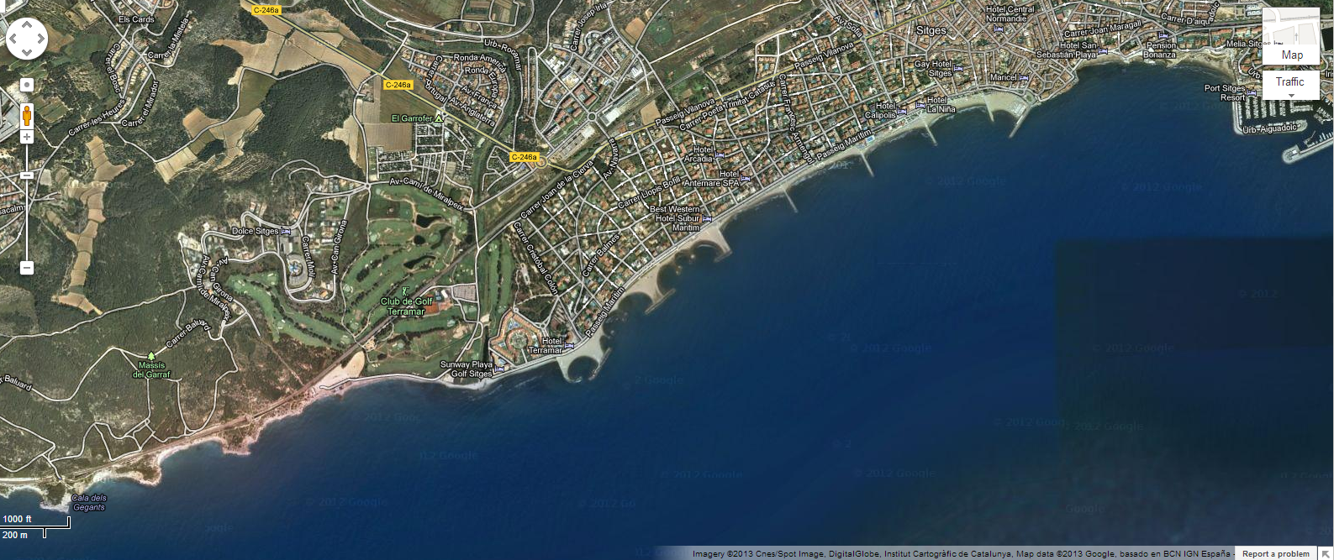

Sitges town centre
Soft rock Beaches 1-6
Rock islets & $$ houses
Beach starvation
Pebble Beach
Hard Rock Headland

