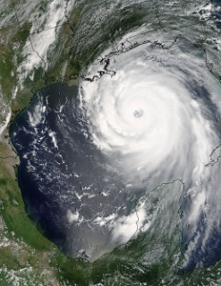
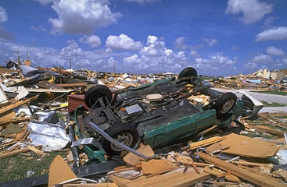
GCSE Geography @ IST
Hazard Number 3 – Tropical Cyclones
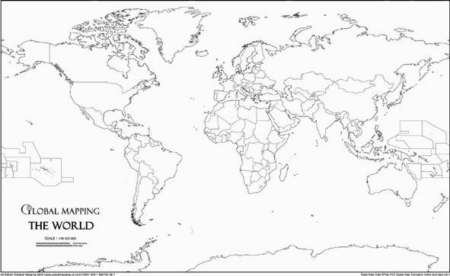
Mapping the location and names of cyclones. Mark on the equator and the two tropics then label each of the three features. Use figure 3.46 on page 134 to help you to plot the data on to your map.

Use an Atlas and the graphic on the Interactive board to complete the following table :
Continent | Two countries affected by tropical cyclone.
Asia | 1  2
Africa | 1  2
North America & Caribbean | 1  2
South America | 1  2
Oceania | 1  2

Which is the only inhabited continent not to experience any regular tropical cyclones ? Explain your answer.
____________________________________________________________________________________________________________________________________________________________________________________________________________________________________________________________________________________________________________
In the space beneath, draw a labelled diagram to show tropical storm formation.

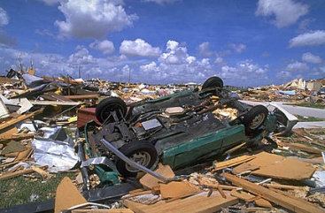

How do tropical cyclones affect people and places ?
________________________________________________________________________________________________________________________________________________________________________________________________________________________________________________________________________________________________________________________________________________________________________________________________________________________________________________________________________________________________________________________________________________________________________________________________________________________
Which global area has seen a rise in the number of tropical cyclones over recent history ?
____________________________________________________________________________________________________________________________________________________________________________________________________________________________________________________________________________________________________________
How will climate change affect tropical cyclones ?
____________________________________________________________________________________________________________________________________________________________________________________________________________________________________________________________________________________________________________

