IGCSE Geography – Climatic Features of the Tropical Biome
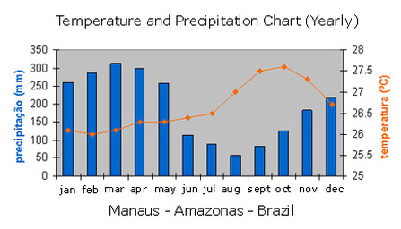
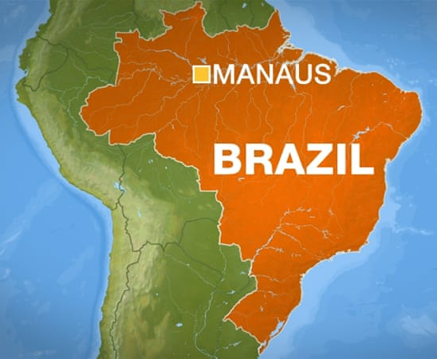

Using Google Maps, write down a detailed location (site & situation) of the city of Manaus.

Site

Situation

Study the climate graph of Manaus above. Complete the following questions based on the graph:

Which is the hottest month?
What is the mean temperature of the hottest month?
Which is the coolest month?
What is the mean temperature of the coolest month?
What is the annual temperature range?
Which is the wettest month?
How much rainfall does the wettest month receive?
Which is the driest month?
How much rainfall does the driest month receive?
How many seasons are there in Manaus?

