IB Geography – Hazards & Disasters
Case Study Summary Sheet for the California Drought 2014 (MEDC)
Where did it happen?
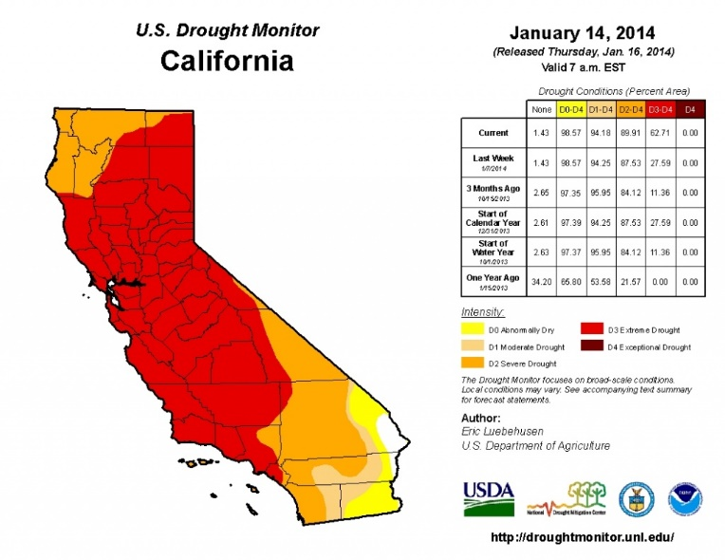
California is a state located on the western coast of the USA. A severe drought in California has depleted snow packs, rivers, and lakes, and groundwater use has soared to make up the shortfall. A new report from Stanford University says that nearly 60 percent of the state's water needs are now met by groundwater, up from 40 percent in years when normal amounts of rain and snow fall. There have been nearly four years of below-normal precipitation and the snowpack (snow on the highest peaks in California) – on which 25 million Californians depend as the source of their water supply – currently is only 10% of what it should be. California’s climate is such that it is generally dry for almost half the year – and relies on rain and snow during the winter season to carry supply through the year. Conditions – in terms of both supply and quality – are unprecedented and serious.
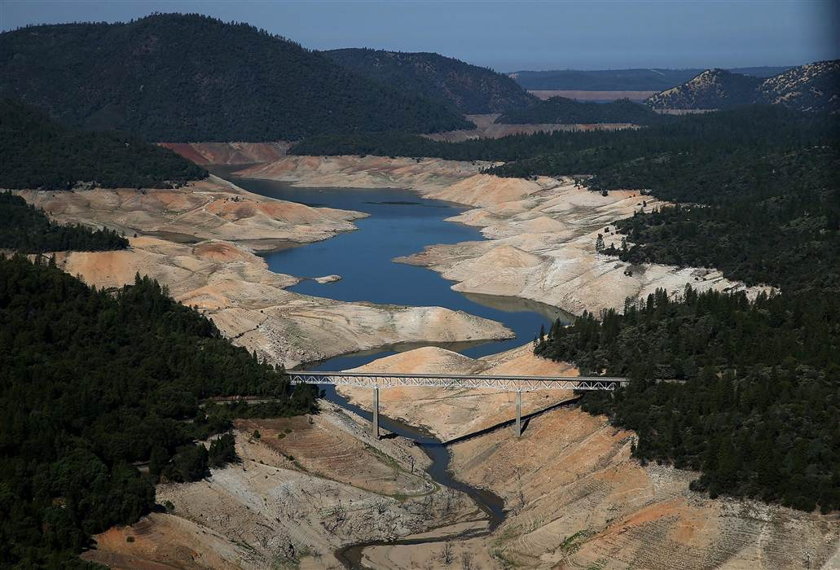

CIA Fact Box – USA Need To Know
Indicator | Values (2014 estimated)
GDP per capita PPP | $52800
People Living in Poverty (less than $2 per day) | 15% of the population
Access to Clean Water | 99.4% of the population
Life Expectancy | 79.56 years
Literacy Rate | 99%
People Per Doctor | 2.42 doctors per 1000 people

When did it happen?
Date. This is a creeping phenomenon and dryer than average conditions started in 2010.
Duration. The drought hazard has been occurring in California for nearly five years and the area remains in drought conditions (2015).

Why did it happen?
Researchers said sea surface temperatures in the equatorial Pacific Ocean set up an atmospheric roadblock off the West Coast of the USA that diverted winter storms away from California. The state relies on winter rain and snow for most of its yearly water. The roadblock is a persistent ridge of high pressure that first formed in 2011 during a La Niña event. Even though La Niña broke down after the 2011-2012 winter, the western equatorial Pacific Ocean remained warmer than average, a pattern known to trigger droughts in the Southwest and California. In a new study, scientists determined that the high-pressure system, dubbed the "ridiculously resilient ridge" by a California forecaster, continued through the 2013-2014 winter because of these favorable ocean temperatures. The pool of warm water generates atmospheric winds that form patterns of high and low pressure (called planetary waves) that can get stuck off western North America as a high-pressure ridge.
Who was affected by it happening?
Social Impacts | Economic Impacts
25 million people reliant on the snowcap and winter rains for their water supply.  Residents are asked to conserve water. It is forbidden to:  - Wash cars  - Water lawns  - Fill swimming pools  Farmers are having to leave thousands of acres of land to fallow (no crops, being left wild).  People have to pay private companies to drill private wells to extract precious groundwater supplies of water. | California has the largest agricultural industry in the USA producing nearly $45 billion a year in revenue. California’s San Joaquin Valley is the salad bowl of the world, providing the majority of fruits and vegetables for the USA.  More farmers will receive economic aid from the U.S government as crops cannot be planted as irrigation is impossible in places.  $5 billion loses in 2014 alone due to losses incurred in the agricultural sector (including wages, processing and transportation). Wine production particularly affected.  Prices of beef and grain rise due to a shortage in supply. Food prices therefore increase to the consumer.
Environmental Impacts | Political Impacts
A huge increase in the drilling on boreholes and wells for industry and residential properties to reach groundwater. Extraction is exceeding replenishment rates and groundwater levels are now seriously low.  Desertification occurring in places on land that has been over cultivated.  Increase in the number of substantial wildfires in the California state. Vegetation is tinder dry and fires spread quickly, engulfing large areas of the state.  The water level in lakes is down up to 240 feet because of the drought. That's equivalent to a 24-story building! | State governors asked Californians to slash their water use by 20 percent.  Fines of up to $500 per violation for breaking the rules as set out in social impacts (above)  The San Francisco Public Utilities Commission has set up a number for people in San Francisco to report water wasters. It also plans to send out staff members to write tickets for those who break the water conservation rules.

What happened? *Leave this until we complete the next section on risk assessment and adjustments & responses to hazards
Management of the drought in California
Before the event

During the event

After the event -

Planning, preparation, prediction, hazard mapping, evacuation, warnings.

Help with recovery, aid - local, regional and international, role of NGOs.
Rescue (short) Rehabilitation (Medium) Reconstruction (Long)

