G8 Geography – The Brandt Line – Teach it or Bin It?
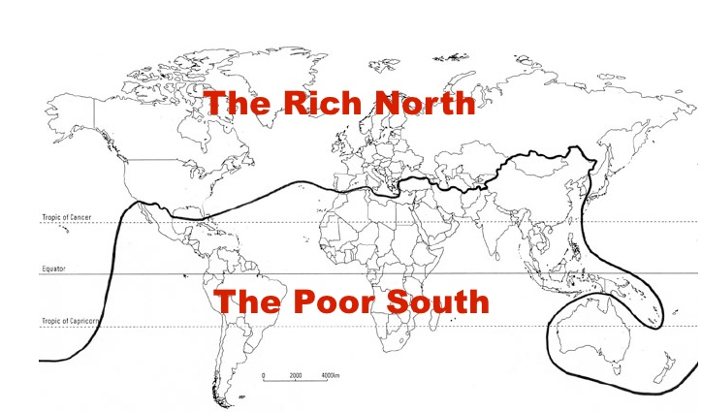

Task 1 – Fill in the data below using the hyperlinks in each column. You need to find the locations of each of the following countries on the map above & highlight (or add a symbol).

Country | Is it in the ‘Rich North’ or ‘Poor South’? | GDP Per Capita  IMF figures | Life Expectancy  Overall | Literacy Rate  If available
France |  |  |  | 99%
China
USA |  |  |  | 92%
Brazil
Iceland
India
Singapore
Indonesia
Romania |  |  |  | 98%

Task 2 – What does GDP per capita mean?
Gross domestic product (GDP) is the total monetary or market value of all the finished goods and services produced within a country’s borders in a specific time period i.e. one year
Gross Domestic Product (GDP) per capita shows a country's GDP divided by its total population to give a value in American dollars.

Task 3 – What does Life Expectancy mean?

Task 4 – What does Literacy Rate mean?

Task 5 – Use Excel to create a comparative bar chart to show the GDP per capita of each of the countries in the table. Paste the graph into the space below
Comment on what it shows - do the ‘rich north’ countries always come above the ‘poor south’ countries?

Task 6 – Use Excel to create a comparative bar chart to show the life expectancy of each of the countries above. Paste the finished graph into the space below
Comment on what the graph shows - do the rich north countries always come above the poor south countries?

Task 7 - Create a comparative bar chart to show the literacy rate of each of the countries above. Paste the graph into the space below
Comment on what it shows - do the rich north countries always come above the poor south countries?

Task 8 - Choose one of the countries above that would really resent being classed as being in the ‘Poor South’. Find out who the leader of that country is and make a note below.
Chosen country:

Leader of the country:

Compose a Donald Trump style ‘angry Tweet’ to United Nations about why they shouldn’t be considered as ‘Poor South’ 280 characters maximum

Task 9 - Is the Brandt Line out of date? Should be bin it or teach it? Outline your ideas in 100 words below.
World Count:

Task 10 - Please now print out your work. When printed, shade in the nine countries on the map on page 1

