**Blue Holes and Base Jumping**

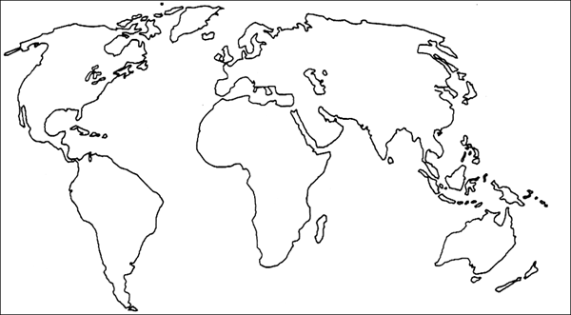**Year 8 – Geography**

Location :

Depth :

How formed :

Key Questions for Investigation

Answers to those questions: (research using the internet)

1  
  
2  
  
3  
  
4  
  
5  
  
6

Where could he have got to?

