G7 Geography - Should We Rethink the Ban on Child Labour? Podcast Task
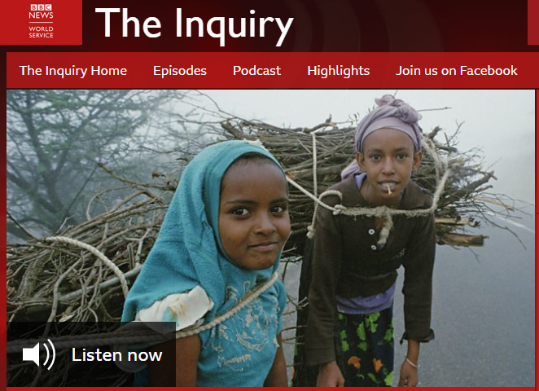
In this 22 minute Podcast, you will hear from 4 expert witnesses. Write some simple notes of that main things that each witness says (do not write everything!)
Witness 1 - Benjamin Smith – Senior Officer for Child Labour, International Labour Organization
Witness 2 - Jo Boyden – Professor of International Development, Oxford University
Witness 3 - Zulema Lopez – former child labourer
Witness 4 - Kavita Ratna - Director of Advocacy and Fundraising, Concerned for Working Children

What are the ‘Top 3’ reasons for keeping child workers and what are the ‘Top 3’ reasons for stopping them working. After listening to the four expert witnesses, fill in the table below.
Keep Child Labourers (workers) | Stop Child Labourers (workers)
1 | 1
2 | 2
3 | 3

So, what do you think about the situation? Aim to write about 150 words in the space below about your thoughts on child labour. Think about what you found out about Meem and think about what you have just heard in the podcast.

