IB Geography – Core – Albedo
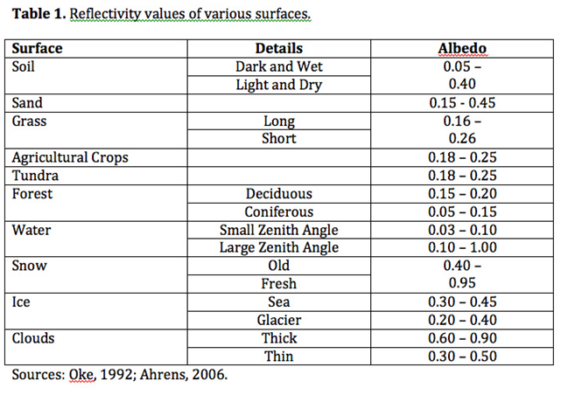

Task 1 – Define Albedo and explain its changes with relation to the surfaces shown in table 1 above

Task 2 – To what extent do seasons alter global albedo levels in the temperate and tundra regions of the northern & southern hemisphere?

