Ageing & Dependency Ratios – IB Geography
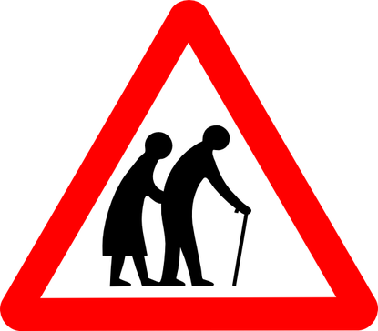

How is the ageing ratio calculated:

Study the PDF report – Demographic Dependency Ratios - attached on geographypods.com.
Is the problem of ageing population just limited to developed countries and their societies?

What does OECD stand for and what do they do?

Turn to the table on page 2 and complete the following activities:

Study the Elderly dependency ratio projected figures for 2050 for OECD down to Latin America & the Caribbean and create a simple bar chart to show the ratio totals for each zone. Paste your Excel graph below.

Comment on the graph above comparing different regions of the world and their future issues with an elderly population. Target 150 words

Create another simple comparative bar chart but this time for the Total Dependency Ratio for the same regions for 2050 projected. Copy the graph into the space provided below.

Comment on the graph above comparing different regions of the world and their future issues with an elderly population. Target 150 words

A good and bad message? Who must shoulder the burden of an increasing dependent population? Why does the current financial crisis make this more difficult?

The situation in Spain.
Read this article from the BBC http://www.bbc.co.uk/news/business-21180371 and then look at the figures for Total Dependent Population for 2050 Spain on the table in the PDF. Outline the issues that Spain faces in the next forty years. What can the country do to reduce this burden? Target 150 words.

Case Study – China’s Ageing Population
Make notes on the videos below (also the videos on geographypods) in the space provided underneath.
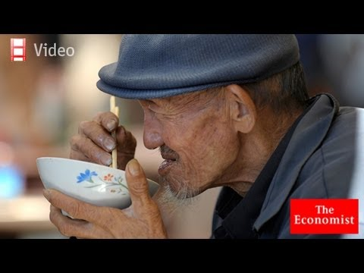
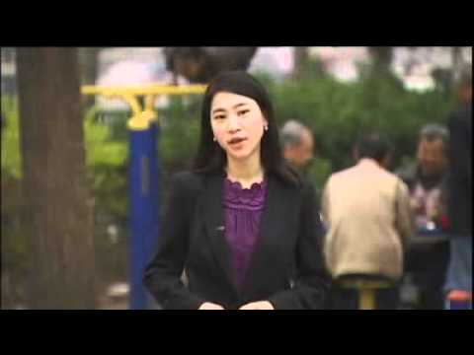

Video Notes – China

Turn to page 17 of the IB Revision Guide and make notes on the advantages and disadvantages of an ageing population. Alternatively, visit the Greenfield Geography Wiki to find out more.
Advantages of an ageing population | Disadvantages of an ageing population

Click the link on geographgypods to be taken to a report on the weird and wonderful methods that different countries have employed to increase birth rates and combat ageing populations. Make in depth notes on at least two different examples.
Case study 1

Case study 2

