IGCSE Geography – Rainforests & Deserts
Spatial Distribution of Global Biomes
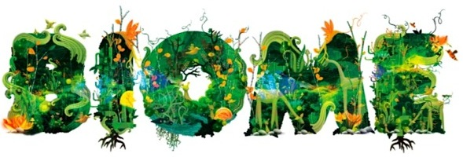
What is a biome?

What is the difference between a biome and an ecosystem?

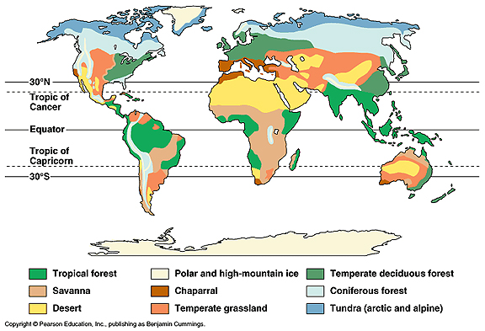

Describe the global distribution of both Desert and Tropical Forest biomes and name three countries in three different continents that host each (that's six in total).
Desert distribution:

Desert Country 1: Desert Country 2: Desert Country 3:

Tropical (rain)forest distribution:

TR Country 1: TR Country 2: TR Country 3:

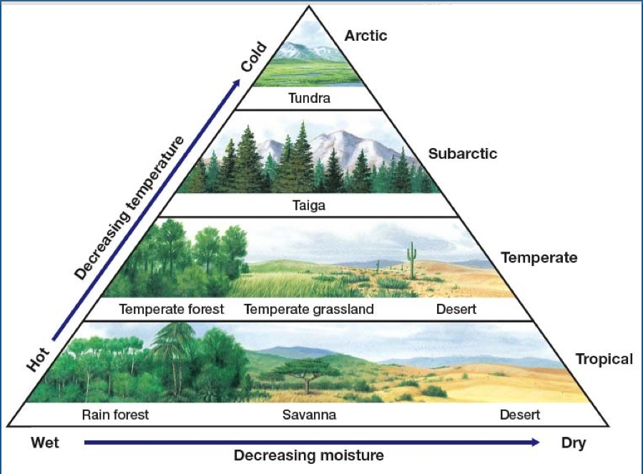

Explain the relationship between temperature & moisture and vegetation generally. How does this apply to both focus biomes (desert & rainforest)?

Personal Geography – Which biomes have you been to? Name the place you visited too.
1.
2.

3.

