Factors Affecting Vulnerability
A community's ability to deal with a hazard event.
Demographic Factors
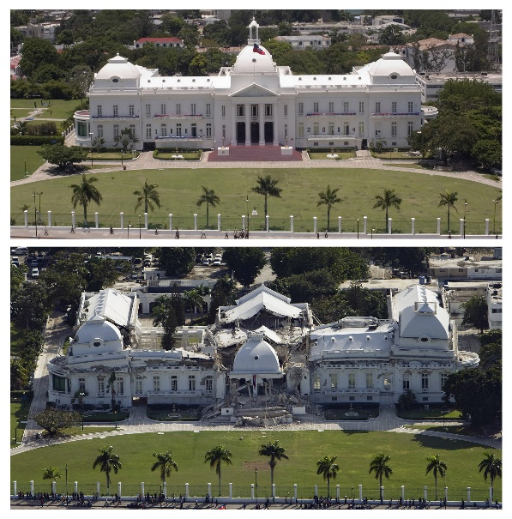
Earthquake in Haiti 2010
Community Preparedness
Socio Economic Factors

