The Brandt Line – Still Relevant in 2014
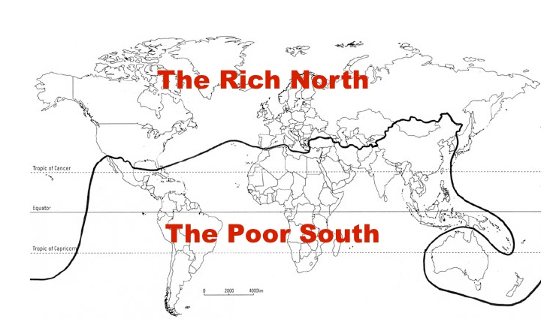
Year 9 - Development

Task – Identify and shade in three countries from the map above that you think no longer fit into the ‘Rich North’ & ‘Poor South’ categories. Write 100 words about each country to explain why you think this. How do you define what it means to be a ‘rich’ and ‘poor’ country?

Country 1 – Name & Explain

Country 2 – Name & Explain

Country 3 – Name & Explain

