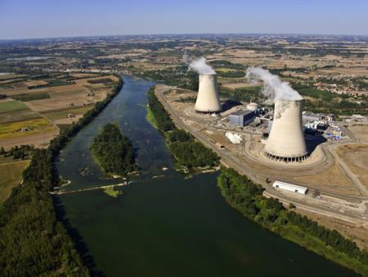
Task 3 - Siting Factors of Golfech Nuclear Plan - France
Demand for electricity nearby ?
Future Population Growth ?
Proximity to settlements
Relief (shape of land) ?
Water Supply ?

