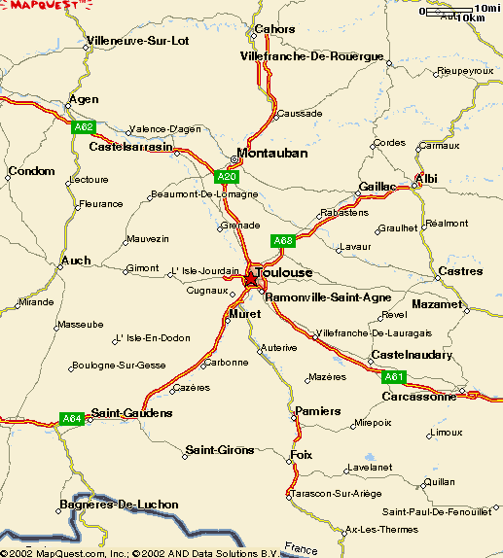**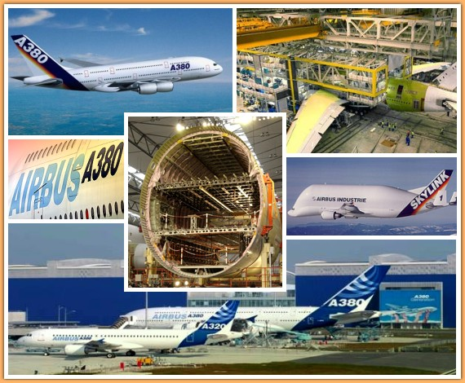iGCSE Geography – Locating Airbus in Toulouse**

Transportation

Existing Industries

Market:

Universities:

Labour:

Location:

Conglomoration