IGCSE Geography – Theme 3 – Industry Case Study
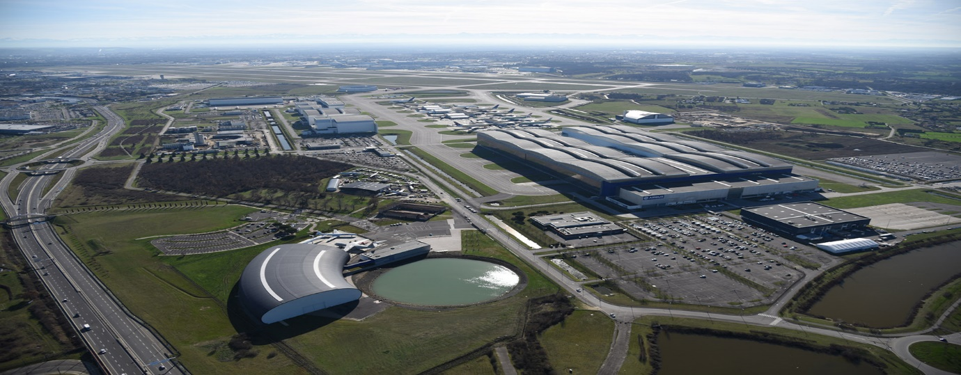
Students at the International School of Toulouse will recognise the image above as the site of aircraft manufacturer Airbus, in Colomiers, France. This location is key for the manufacture of aeroplanes, and the company produces up to 700 aircraft per year! This short unit of work will use Airbus and its site in Toulouse as the case study of why this site is particularly suitable for this type of industrial activity.

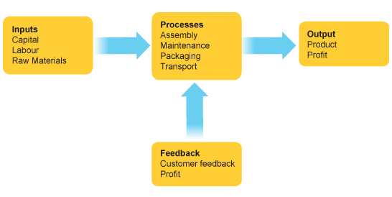
You will remember a similar diagram to the one above from your work on agriculture earlier in Theme 3. It shows the general inputs, processes and outputs in an industrial system. This can be applied to Airbus too and their production of aircraft like the one below.
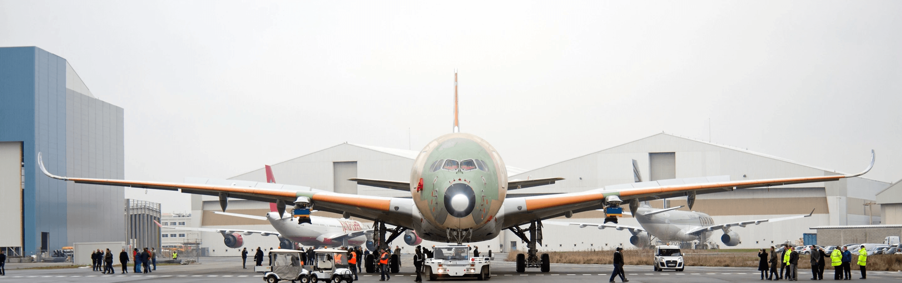

Task 1 – Copy and paste the statements in the table at the bottom of this page into the correct row below.
INPUTS

PROCESSES

OUTPUTS

The new FAL assembly plant will allow for 75 x A320 Family aircraft to be constructed every month by the year 2026. The total site in Toulouse totals 700 hectares | In 2022, Airbus was given a €111 million subsidy by the French government. The funding shows how important Airbus is for the French government. | The Airbus A300-600ST (Super Transporter), or Beluga, is a specialised wide-body airliner used to transport aircraft parts and outsize cargoes | Airbus headquarters are located near the Toulouse-Blagnac Airport. In Toulouse more than 35,000 people are Airbus employees. | Plane parts are made of steel and titanium, while almost 20% is made from aluminium-lithium, to decrease the weight of aluminium while improving its strength
The price of a brand-new Airbus A320 starts at around $101 million, but this does not include optional features or customizations. | Airbus on posted an 11 percent drop in net profit to €3.8 billion euros ($4.1 billion) in 2023 | The A350 final assembly line is the “greenest” ever built by Airbus, with features including natural lighting wherever possible and a photovoltaic roof that produces the equivalent of 55% of the power needed for the building to function | In Toulouse, 4,500 employees work in such central functions as finance, marketing, engineering, customer support programmes and procurement. | European aviation company Airbus working with French shipping company Louis Dreyfus to replace its existing fleet of ro-ro cargo ships with three new fuel-efficient vessels to transport aircraft components across the Atlantic.

Why are Airbus located in Toulouse?
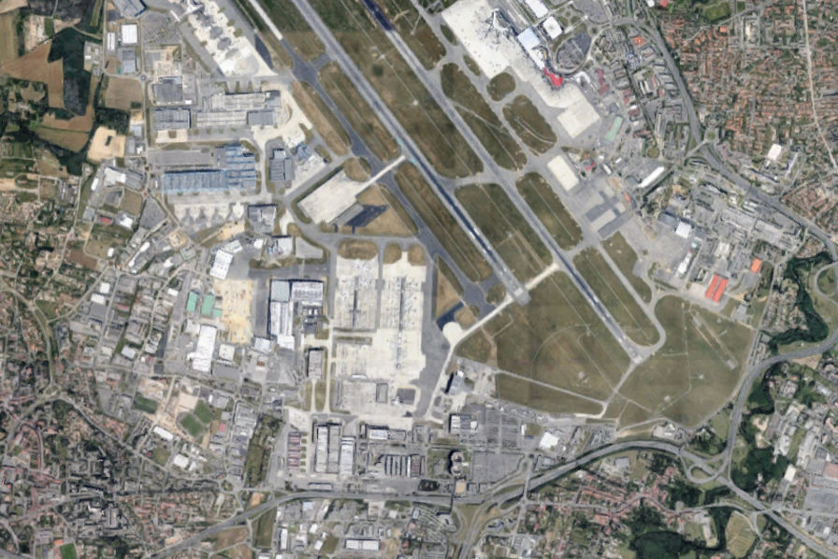
Task 2- Use your own knowledge of Toulouse and the Airbus site close to our school to explain why each of the factors was important in the development of this aviation industrial zone. This help sheet is useful.
Land
Labour (workers) | There are 30 different universities in Toulouse, including the École nationale supérieure de l'aéronautique et de l'espace & Lycee Airbus. Skilled labour is in plentiful supply & population of Toulouse is 1.5 million!
Raw Materials
Fuel & Power | Energy is plentiful thanks to a mixture of energy from both HEP schemes in the French Pyrenees and the large nuclear power facility (Golfech) near Agen. Airbus also uses renewable energy.
Transport
Markets
Political Factors

Airbus and the unwanted output – WASTE!

Task 3 – One of the issues caused by massive scale production of aeroplanes in Toulouse is the inevitable waste and pollution that is caused. Watch this video (in French) and make notes on how Airbus is trying to reduce their waste and environmental impact (decarbonisation) of their Toulouse site.

Task 4 – You should also be able to describe and explain the siting factors of the types of industries below. Siting factors means
Type of industry | Describe the siting factors | Explain why important
Manufacturing
Processing
Assembly
High Technology

